

Career Transition  
Assistance Program  
2019–2021  
Evaluation Report

Published November 2022

ISBN

978-1-76114-493-6 [PDF]  
978-1-76114-494-3 [DOCX]



With the exception of the Commonwealth Coat of Arms, the Department’s logo, any material protected by a trade mark and where otherwise noted all material presented in this document is provided under a [Creative Commons Attribution 4.0 International licence](https://creativecommons.org/licenses/by/4.0/)  
(https://creativecommons.org/licenses/by/4.0/).

The details of the relevant licence conditions are available on the Creative Commons website (accessible using the links provided) as is the full legal code for the [CC BY 4.0 International](https://creativecommons.org/licenses/by/4.0/legalcode) (<https://creativecommons.org/licenses/by/4.0/legalcode>).

The document must be attributed as the Career Transition Assistance Program 2019–2021 Evaluation Report.

Wallis Social Research and ACIL Allen Consulting were commissioned by the (former) Australian Government Department of Education, Skills and Employment to evaluate the Career Transition Assistance program between July 2019 and March 2021.

This report outlines the findings of the evaluation and includes a departmental response.

Table of contents

A note to readers on the interpretation of qualitative findings vi

Definitions: key terms in the report vii

1 Executive summary viii

Departmental response to findings xii

2 Background 2

2.1 The challenges faced by mature age job seekers 2

2.2 Digital literacy challenges facing mature age job seekers 3

2.3 Overview of the Career Transition Assistance program 4

2.4 Evaluating the Career Transition Assistance program 5

2.5 Methodological overview 8

2.6 Quantitative component 9

2.7 Qualitative component 12

3 Program delivery 14

3.1 Activities and outputs 14

3.2 Qualitative findings on CTA program delivery and structure 19

4 Overall experiences of the CTA program 30

4.1 Overall participant perceptions of the CTA program 30

4.2 Program components 32

4.3 Program delivery during COVID-19 restrictions 35

5 Outcomes 40

5.1 Digital literacy among participants immediately post-program 40

5.2 Short-term outcomes 43

5.3 Experiences post-CTA 53

5.4 Longer term outcomes 59

6 Delivery in the COVID context 69

6.1 CTA delivery during COVID 69

6.2 Challenges in delivery due to COVID-19 restrictions 72

6.3 CTA participant perspectives on delivery 73

7 Conclusions and recommendations 75

7.1 Areas for improvement 77

7.2 Recommendations 78

List of figures

Figure 1 Respondent types vii

Figure 2 CTA: Program Logic Model 5

Figure 3 The CTA program: key areas of evaluation 6

Figure 4 Overall evaluation methodology flowchart 8

Figure 5 Quantitative surveys methodology overview 10

Figure 6 Summary of qualitative fieldwork 12

Figure 7 Unemployment duration, CTA participants (1 July 2019 to 31 March 2021) 14

Figure 8 CTA participants by jobactive stream (1 July 2019 to 31 March 2021) 15

Figure 9 Characteristics of CTA participants (1 July 2019 to 31 March 2021) 15

Figure 10 Mean satisfaction and likelihood to recommend ratings – across CTA program types 30

Figure 11 Activities or topics covered – as part of Functional Digital Literacy 32

Figure 12 Activities and topics covered – Tailored Career Assistance 34

Figure 13 Delivery format experienced during COVID 35

Figure 14 Delivery formats accessed during COVID delivery CTA 36

Figure 15 Selected participant quotes on delivery formats 37

Figure 16 Frequency of, and satisfaction with, combinations of delivery methods 38

Figure 17 Percentage using digital devices daily or more often 40

Figure 18 Confidence in using digital technology 41

Figure 19 Attitudinal sentiment regarding technology 42

Figure 20 Improved digital literacy 44

Figure 21 Increased ability to use digital platforms 45

Figure 22 Increased use of digital job search activities 46

Figure 23 Improved confidence 47

Figure 24 Social connections 49

Figure 25 Improving job search skills 52

Figure 26 Respondent status immediately post-CTA 53

Figure 27 Full-time versus part-time work 54

Figure 28 Employment category 55

Figure 29 Self-evaluation of quality of main job 56

Figure 30 Helpfulness of CTA and jobactive providers in getting through to the interview stage 57

Figure 31 Most valuable aspect of the assistance from the CTA provider 58

Figure 32 Confidence in finding a job in the next 12 months 59

Figure 33 CTA percentage working by wave 60

Figure 34 Post-CTA pathways 61

Figure 35 Proportion of CTA program participants working over time, by stream 62

Figure 36 Percentage who had increased their use of various digital activities 63

Figure 37 Percentage net agree: during COVID-19 64

Figure 38 Self-described physical and mental health over time 65

Figure 39 Percentage no probable severe mental illness 66

Figure 40 Resilience in the last 12 months 67

List of tables

Table 1 Breakdown of survey completions 11

# A note to readers on the interpretation of qualitative findings

Regarding the results which follow, the reader is reminded that qualitative research seeks to develop insight and direction rather than provide absolute measures.

Given the sample sizes, the special recruitment methods adopted and the objectives of the study, it should be understood that qualitative research work is exploratory in nature.

There are no statistical degrees of confidence in qualitative findings and they are not necessarily representative of the broader population.

Qualitative findings should therefore be viewed as a frame of reference and indicative in their nature.

**Wallis Social Research / ACIL Allen Consulting**

# Definitions: key terms in the report

|  |  |
| --- | --- |
| Term | Definition |
| **CTA program** | Career Transition Assistance program |
| **CATI** | Computer-Assisted Telephone Interviewing |
| **Longitudinal** | Research design that involves repeated surveying of the same people over a period of time. |
| **Participant and non-participant** | A participant is a person who completed the CTA program. Non-participants are eligible individuals who did not participate. |
| **Cohort** | This means a group of participants. A cohort can comprise:  a) CTA trial cohort: participants in the CTA trial  b) CTA program cohorts: participants in the CTA program  c) Comparison cohort: a group of non-participants who would be eligible for CTA but who have not been involved with the CTA program, and who have agreed to participate in the quantitative research  d) COVID delivery cohort: a group of CTA participants who participated in the program during the period of flexible delivery of the CTA program during 2020. |
| **Completion date** | a) For CTA participants, the date at which they completed the CTA trial or program.  b) For non-participants, the date at which they agreed to participate in the quantitative research.  Due to a lack of data for completion dates, assumptions were made in conjunction with the department about the participant start dates and expected completion dates based on the length of the CTA activities. |
| **Wave 1 survey** | The quantitative survey that was distributed to a cohort on its completion date, or as soon as possible thereafter. |
| **Wave 2 survey** | The quantitative survey that was distributed to a cohort 3 months after the Wave 1 survey. Therefore, all cohorts received their Wave 2 survey the same number of months after their Wave 1 survey. |
| **Wave 3 survey** | The quantitative survey distributed 9 months after the Wave 1 Survey. |
| **Wave 4 survey** | The quantitative survey distributed 15 months after the Wave 1 Survey. |
| **Wave 5 survey** | The quantitative survey distributed 18 months after the Wave 1 Survey. |
| **COVID delivery survey** | The quantitative survey completed by CTA participants during the 2020 COVID-19 restrictions (March 2020 – December 2020). During COVID-19 restrictions, CTA was either delivered entirely online, continued to run in person, or used a mixture of online and in person. |

There were 7 respondent types, which are labelled in Figure 1. The icons associated with each respondent type are used to indicate respondent type in the body of the report.

Figure 1 Respondent types

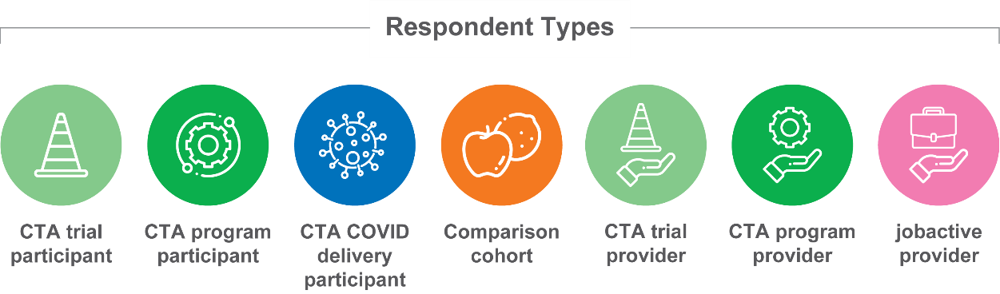

Executive summary

|  |
| --- |
| Wallis Social Research and ACIL Allen Consulting was commissioned to evaluate the Career Transition Assistance (CTA) program. This report outlines the findings from the research.  The fieldwork consisted of a longitudinal survey among CTA participants and a comparison cohort. It also included extensive consultations with participants, CTA providers, jobactive providers, and other stakeholders. |

|  |
| --- |
| Background |

Mature age job seekers face challenges in the Australian job market arising from the transformation of the economy and the increasing digitisation and skill level required for many jobs. Mature age job seekers can potentially face particular barriers in securing work, particularly if changing from one career to another after a long career.

The Australian economy is transitioning towards a service and knowledge-based economy and this trend is projected to continue. As digital technologies continue to play a transformative role in the future of work and the way we live, it will be important to ensure that everyone has the necessary knowledge, resources and skills to be able to work and live in an increasingly digital environment.

The Australian Government announced the CTA program in 2017 in response to the challenges faced by mature age job seekers and gaps in the provision of tailored employment services. Mature age job seekers aged over 45 years of age are eligible to be referred to the CTA program if registered with eligible Australian Government employment services. Prior to the national rollout of the CTA program in July 2019, the Australian Government ran a CTA trial (for those aged 50 and over) which commenced in July 2018.



**Executive summary**

|  |
| --- |
| Evaluating the CTA program |

The department developed a Program Logic Model for the CTA program which outlined both immediate/short-term and longer term outcomes. The overall objective of the CTA program is to provide career assistance, training and coaching tailored to help mature age job seekers improve digital literacy, become more competitive in the local labour market and secure employment. The evaluation centred on 6 key areas: digital literacy, job search skills, employability, resilience, employment outcomes and CTA program satisfaction.

The evaluation also recognises the concept of human capability, which provides a framework where a broader range of outcomes are acknowledged, over and above directly measurable economic and employment outcomes. These can include wellbeing, health, social relationships, resilience and confidence. In addition to being important in and of themselves, these outcomes can be considered as important foundational contributors to work readiness.

|  |
| --- |
| CTA program delivery |

CTA participant profile

In the period covered by the evaluation (July 2019 to 31 March 2021), 11,085 job seekers were referred to the CTA program, with around 75% (8,407) commencing the course. These participants were generally evenly distributed across age groups and gender.

Of those commencing the course, 58% had been unemployed for a period of 12 months or more. Of CTA participants surveyed, 71% reported completing the course.

Program delivery and structure

CTA providers agreed that the CTA program is well designed to meet the needs of mature age job seekers. It recognises the unique challenges this cohort faces and is well tailored to their needs. As well as developing skills in the areas of digital literacy and job searching, the CTA program contributes to human capability attributes which can be a precursor to employment: the building of resilience, networks and confidence.

The group setting is a key design component of the CTA program, and was highly regarded by participants and providers. It encourages the formation of bonds between the course facilitator and participants, and between participants, which can help underpin the development of new knowledge and skills.

Facilitators are also a critical component of the CTA program. The quality of these individuals, both as teachers/trainers and as motivators, is valued highly by participants.

A number of challenges were encountered as part of CTA program delivery: rolling commencements can be disruptive, meaningful engagement with employers proved challenging for many CTA providers, and feedback suggests that the ‘warm handover’ back to their employment services provider didn’t always deliver as much utility as initially planned.

|  |
| --- |
| Experiences of the program |

CTA participants provided high ratings for overall satisfaction, and most would have recommended the CTA program to others in a similar situation. This was reinforced through the qualitative research, where participants were generally enthusiastic in their praise of the CTA program.

There were small, although consistently noted, differences in satisfaction across the CTA trial and program, and the COVID-19 remote delivery version of the CTA program (during the period covering March-September 2020), with participants providing the highest overall ratings for the face-to-face version of the program.

Discussions with participants and providers revealed that much of the enthusiasm for the CTA program came from benefits over and above improved digital literacy and job search skills. Many CTA participants reported benefits of increased confidence in their own abilities, as well as a sense of relief that they were ‘not alone’ in facing a challenging job search environment. Many of these benefits were underpinned by the sustained group environment, and the ability of the facilitator to manage this dynamic successfully.

Meaningful engagement with employers was challenging for providers to coordinate, citing compliance/regulatory requirements and a general lack of time for employers to devote to this. This is one element that participants were particularly keen to participate in. Providers found that, while some employers were even less available during the 2020 COVID-19 delivery period, others used the new delivery methods presented by the restrictions as an opportunity to participate.

During the COVID-19 delivery period, a wide variety of delivery modes and combinations were employed, with varying levels of sophistication. The most successful delivery modes (in terms of participant satisfaction) incorporated online delivery in group settings, with the inclusion of additional smaller-group interactions.



|  |
| --- |
| Outcomes |

Short-term outcomes

Immediately post-program, CTA participants reported higher levels of digital confidence than their comparison group counterparts.

CTA participants reported improvements related to their use of digital devices, in terms of both everyday use and applied use – harnessing digital technology to enable more effective job searching.

Of CTA program participants surveyed, 78% agreed that CTA training improved their ability to use digital devices. This figure was lower for trial participants (73%) and for participants during the COVID delivery period (66%). Further, 81% agreed that the training had made them more open to using digital tools when looking for work.

CTA participants also reported improvements relating to career transition and job searching skills. These were more pronounced for skills relating to researching and applying for jobs but were also evident for interview-related skills.

In addition to digital skills and applied job search skills, many CTA participants reported improvements to skills related to human capability. These included improvements in confidence, as well as social skills and engagement. For example, 87% of program participants agreed they had gained confidence from the training, and 69% reported feeling confident about finding a job in the next 12 months (compared to 55% in the comparison group).

Post-CTA activities

Shortly after completing the CTA program, most CTA participants were still looking for work, although some had moved into employment, self-employment or further study. Those who were looking for work and who had secured a job interview were more likely to credit the CTA program with being helpful in this outcome, compared with their jobactive provider.

CTA participants who had secured employment still faced challenges. Many of the jobs gained were not permanent positions, and a majority of workers would have welcomed the chance to work more hours. Nevertheless, most were positive about their employment, with around 9 in 10 agreeing that they were able to use their existing skills and gain useful experience in their new roles.

Longer term outcomes

The employment results for the comparison group were markedly higher (25%) than for the CTA cohorts at wave 1 of the survey (just after completing the program). Such a difference could indicate that the groups were not entirely similar. Nevertheless, over the course of the survey (18 months post-participation), CTA participants narrowed the employment gap with the comparison group to just 10% by the time of the Wave 5 survey. It should be noted that sample sizes for this question were quite low and that this data was self-reported.[1]

The consistently higher employment results for the comparison group may suggest success in targeting the CTA program towards those who face a greater level of labour market disadvantage and need for additional assistance before jumping into job searching. This result could also potentially be explained simply by the delay in job seeking activities for CTA participants while participating in the program.

It is not possible to identify the full scope or cause of any difference in employment outcomes using data collected in this research. This could potentially be a worthwhile topic for further research into the CTA program.

CTA participants tended to report stable health and wellbeing indicators across the period of the survey. Given the context of a global pandemic and continuing labour market struggles, this would appear to be a very good result. There was greater variation in the scores across the comparison cohorts, but overall, self-reported health and wellbeing of CTA participants was generally similar to those among the comparison group.

|  |
| --- |
| Delivery in the COVID-19 context |

Most providers were able to transition the CTA program to remote delivery in response to COVID-19. Overall, the transition was effective, and often occurred more smoothly than stakeholders might have expected. Sometimes, the shift to remote delivery resulted in an enlargement of the facilitator role, with these individuals delivering both training and operational support. Some CTA providers were in a position to provide additional staff resourcing to this aspect, but this was not universal. As a result, some providers experienced hidden costs in the rapid deployment of the remote delivery CTA program.

There was a mix of reported impacts on the group dynamic as a result of online delivery. Some CTA providers reported that the quality of the group dynamic was not significantly impacted by the move online and noted that it allowed greater scope for one-on-one support. Other providers noted that the group dynamic was constrained by the online delivery. Participants had less of a frame of reference but were generally less emphatic about the advantages of the group dynamic as part of their online experience of CTA.

One of the chief benefits of the shift online for the CTA program was the identification of new opportunities for more effective engagement with employers. While CTA providers had traditionally struggled to arrange on-site visits (either outbound or inbound) due to logistical issues, the use of videoconferencing made this process much easier for some providers.

Some of the chief challenges with the delivery of CTA online included the onboarding of participants, and the technological challenges faced by new participants accessing the various platforms.

|  |
| --- |
| Recommendations |

* Consideration of online components may allow a broadened reach based on geographies and differing levels of ability. It will potentially be even more important into the future given the increasing number of mature age job seekers and impacts of COVID-19 leading to increased use of digital technologies.
* The positive design elements of the CTA program, particularly its flexibility, use of group settings and trained facilitators, continuity of service and focus on transferable skills, should be considered and factored into the design and delivery of other employment-related programs.
* Given the success of providers in continuing to deliver the CTA program online during COVID-19 restrictions and the positive results from online delivery, consideration should be given to continuing to offer the program through a blended delivery model.
  + This is particularly relevant in remote and regional areas where there are thin markets and significant travel costs for participants.
  + This would also help extend the reach of the CTA program, increase flexibility, improve sustainability, reduce travel and other costs for participants and potentially increase the uptake of digital technologies.
  + It would need to be supported at referral stage by a checklist for technology support requirements in relation to appropriate devices and data plans. It may also need a small and separate bridging module for those requiring the very basic skills in accessing online delivery, albeit many CTA providers were able to address this during COVID.
* The department could look to strengthen the employer engagement model by promoting best practice examples of employer engagement and providing increased work experience opportunities. This would be valuable in terms of building skills in the workplace and also breaking down any potential barriers related to age.
* In terms of program design, there should be a greater focus on referrals, completions and outcomes, for example:
  + greater promotion of case studies and outcomes from the CTA program in order to support increased referrals from jobactive providers
  + providing visibility and feedback to CTA providers on employment outcomes and increased feedback from jobactive providers after the final ‘warm handover’.
* The department should work with CTA and jobactive providers to improve the quality of data on key outcomes from the CTA program including data relating to completion rates, improvements in job search activities (including the number of interviews secured), and employment outcomes.
* Consideration should be given to incorporating health and wellbeing elements into the program. This could include discussion of mental health issues, encouraging participants to monitor their mental health, referring and providing access to support services, and following up on participants post course completion.

# Australian Government Department of Employment and Workplace Relations.Departmental response to findings

Career Transition Assistance context

The Career Transition Assistance (CTA) program evaluation provided insights highlighting strengths within the program, as well as identifying areas for potential improvement and offering recommendations on how to achieve greater benefits for participants and providers.

The department agrees with the findings and recommendations of the evaluation.

The evaluation found that CTA participants provided high ratings for overall satisfaction, and most would have recommended the CTA program to others in a similar situation. The evaluation also highlighted positive results for participants, including:

* improvements in digital confidence and the use of digital devices
* improvements to resilience and confidence
* enhancements to job search and interview skills.

Next steps and enhancements

The CTA program has continued under Workforce Australia Employment Services, which commenced on 1 July 2022. Recommendations and findings from the evaluation were used to inform changes to the CTA program under Workforce Australia, including:

Retention and expansion of program

Given the positive evaluation findings, CTA is continuing and has moved to a demand-driven funding model for Workforce Australia Employment Services. This will allow participants to be referred to CTA as needed rather than limiting referrals based on a capped funded amount.

Eligibility has also been expanded to include Disability Employment Services participants.

Program design

The evaluation noted positive program design elements and recommended the inclusion of health and wellbeing elements into the program. Elements of the program considered positive by participants and providers have been retained, such as flexibility, tailoring of services, delivery of training in a group setting (50 out of 75 hours must be delivered in a group setting), trained facilitators and a focus on transferrable skills.

Participation has remained voluntary and can contribute towards the new Points Based Activation System.

Additionally, the ‘rolling start’ model has been changed to a block scheduled training model. This change recognises findings from the evaluation that the rolling start model could be disruptive for both participants and providers. The department may consider requests for rolling model courses on an exception basis where providers can demonstrate the format meets participant needs.

In line with the recommendation to include health and wellbeing elements in the program, connecting participants with information regarding local resources to support their health and wellbeing has been added as a core course component.

Consideration of online components

The evaluation noted the positive results from online service delivery and recommended that consideration be given to offering CTA through a hybrid delivery model. Under Workforce Australia Employment Services, CTA providers have the ability to deliver courses in a hybrid format where this maintains the intent of the program. This may include fully online servicing which can be delivered with departmental approval.

This recognises that the use of hybrid service delivery is particularly beneficial for participants in regional areas or areas with limited transportation options, and that virtual participation can have a positive impact on increasing digital literacy skills through the use and practical application of technology.

Strengthened employer engagement

The evaluation recommended strengthening the employer engagement model, including through work experience opportunities. From 4 July 2022, CTA program settings place a greater expectation on CTA providers to develop and maintain linkages with employers and industries in the local region to deliver relevant experiences for participants, through inbound and outbound employer visits. This expectation was outlined in the CTA Statement of Requirements in the Request for Proposal for the New Employment Services Model 2022. Providers have been awarded contracts to deliver CTA based, in part, on each organisation’s ability to demonstrate its strong linkages with employers and industries in their local regions.

Following a pause on referrals to the National Work Experience Programme through placement management services from 1 July 2022, providers were advised of the cessation of the National Work Experience Program effective from 9 September 2022. The government will consider alternative work trial settings that better meet its expectation that participants should receive payment commensurate with award wage rates in the context of the Select Committee into Workforce Australia Employment Services.

Conclusion

Consistent with findings and recommendations outlined in the CTA program evaluation, the department has retained program design elements that support the objectives of the program. The department has also expanded eligibility to Disability Employment Services participants and introduced changes to the program based on recommendations from the evaluation that are expected to deliver an improved experience and positive benefits for participants. The department is committed to continuous improvement of the CTA program informed by evidence and will continue to closely monitor the CTA program following the introduction of Workforce Australia Employment Services.



# 

# Background

## The challenges faced by mature age job seekers

**Mature age job seekers are facing increasing challenges in the Australian job market arising from the transformation of the economy and the increasing digitisation and skill level required for many jobs.**

The Australian economy has undergone significant structural change in recent decades, shifting away from manufacturing and agricultural industries with employment growth in service and professional occupations.[2]

Mature age workers will be playing a greater role in the Australian economy as the working age population shifts progressively into older age brackets. The ageing population over the coming decades could have major impacts on the labour market.[3] This trend is predicted to lead to an overall fall in participation rates, with mature workers more likely to work reduced hours. This could also lead to greater reliance on income and welfare support to assist mature age displaced workers to return to the workforce or to be supported while they seek reintegration into the labour market.[4]

As at 31 March 2020, job seekers aged 50 and over made up over 26% of the caseload for jobactive providers, higher than for job seekers under the age of 25 (around 18%).[5] Changes in both the labour market and government policy such as increases in the eligible pension age are likely to increase the percentage of mature age job seekers in the jobactive provider caseloads.

Australia’s labour force participation rate for people aged 45 to 54 was approximately 84.6% in 2019, and 67.2% for those aged 55 to 64 years. The latter rate, while higher than the OECD average of 64.4%, was lower than in other developed economies such as New Zealand (78.4%), Switzerland (76%), Sweden (81.7%) and Germany (74.7%).[6]

Mature age workers were also hit harder by job losses arising from COVID-19. It was estimated that 30% of the job losses arising from the recession were people aged between 51 and 65 years. This is because many of these workers are in sectors that were most impacted by the recession including education and training, retail trade, accommodation and hospitality.[7]

Mature age job seekers can potentially face additional barriers in securing work. In Australia, these barriers can include persistent ageism and negative stereotypes, lack of consideration of age as part of diverse and inclusive workplaces, reluctance to incur higher salary costs, and a perceived lack of up-to-date skills among mature age workers.[8]

The Australian Human Rights Commission (AHRC) 2016 Willing to Work report found that older workers faced significant barriers to employment. Employer perspectives canvassed by the inquiry identified a number of key issues regarding mature age workers and job seekers, including a lack of understanding of the knowledge and skill set of mature age employees and job seekers, negative assumptions about their capacity to adapt or learn new technical skills and a general assumption they will not be in the role as long as younger workers. The report concluded there was a need for a national plan and campaign to address employment discrimination and dispel myths and stereotypes about the employment of older people, as well as those with a disability.[9]

A survey undertaken by the former Department of Employment, Skills, Small and Family Business[10] indicated that employers valued mature age workers’ (55 years and older for the purposes of this survey) relevant experience and knowledge and employability skills. Employers suggested several ways that mature aged job seekers could improve their job search success, including undertaking further training to ensure relevant skills and experience, and identifying relevant skills and strengths and how these could apply to jobs.

Research undertaken by the Brotherhood of St Laurence on the effectiveness of employment services for mature age job seekers found that:

* employers interviewed (n=21) demonstrated some reluctance to hire mature age workers, most commonly because of a perception of this group having limited digital skills. Some also mentioned the importance of identifying and demonstrating how their skills were transferrable and relevant to the role when applying for positions with employers
* there was a view among mature age job seekers themselves that digital literacy training was not on offer in employment services
* mature age workers could benefit from assistance identifying transferable skills and some assistance with developing digital literacy, but jobactive staff had limited time to do so.

## Digital literacy challenges facing mature age job seekers

The Australian economy is transitioning towards a service- and knowledge-based economy and this trend is projected to continue. Over the last 30 years employment in sectors such as health care and social assistance and professional, scientific and technical services has increased by 163% and 226% respectively compared with a decline of 22% in employment in the agricultural sector and a 27% decline in manufacturing employment.[11]

It will be increasingly important, therefore, that mature age workers have the requisite digital literacy skills for employment not only from a personal point of view but also for the future growth and productivity of the Australian economy as a whole.

Digital literacy was one of 10 core competencies relevant to most occupations and industries (otherwise known as foundational, soft or employability skills) identified by the National Skills Commission as part of their work on the Australian Skills Classification project.[12] The National Skills Commission defines this skill as ‘Identifying and using technology (including hardware and software) confidently, creatively and critically’.

The latest results from the Australian Digital Inclusion Index 2020 (ADII) show that people on low incomes, those with low levels of education, and seniors have the lowest levels of digital inclusion, with levels of digital inclusion generally declining with age.[13]

The ADII rates digital inclusion on a scale ranging from zero to 100. Those aged 25 to 34 have consistently been the most digitally included age group from 2014 to 2019; however, the 35 to 49 year age group overtook them in 2020 as the most digitally included age group. Those aged 50 to 64 were only 1.3 points below the national average, but 7.4 points below the 35 to 49 year age group. This changes markedly for the 65 years and over group, who are the least digitally included group in Australia with a score 13.3 points below the national average. Those in regional and rural areas also face greater digital literacy barriers. Regardless of age, digital inclusion tends to increase as income, education and employment levels rise.





## Overview of the Career Transition Assistance program

The Australian Government announced the CTA in 2017 in response to the challenges faced by mature age job seekers and gaps in the provision of tailored employment services. The CTA program was part of the government’s $110 million Mature Age Employment Package delivered under the Working Age Payments Reforms in the 2017–18 Federal Budget.

As part of the 2018–19 Federal Budget’s $207 million More Choices for a Longer Life Package, it was further announced that CTA would be available nationally from 1 July 2019. The Australian Government also announced it would lower the eligibility age from 50 years and over to 45 years and over. In response to COVID-19, the government invested $41.7 million to fund the CTA program separately from the Employment Fund to make it quicker and easier for mature age job seekers to access it.

Mature age job seekers aged over 45 years are eligible to be referred to CTA if registered with Australian Government employment services including jobactive, the New Employment Services Trial, and Online Employment Services.

Prior to the national rollout of the CTA in July 2019 the Australian Government ran a CTA trial which commenced in July 2018. The trial was based in 5 trial regions: Adelaide South, South Australia; Ballarat, Victoria; Central West, New South Wales; Perth North, Western Australia; and Somerset, Queensland.

|  |
| --- |
| The key services include:  * Functional Digital Literacy training to increase participants’ knowledge and confidence in using digital equipment and devices to apply for jobs and use in the workplace * a career assessment and development of a Career Pathway Plan * tailored assistance with résumés and job interview skills * exploration of job opportunities and local industry need * identifying transferable skills relevant to local jobs * better engagement with employers and different industries * increasing participant motivation and resilience * a ‘warm handover’ providing the opportunity for a meeting between the participant, the CTA provider and the jobactive provider to discuss what had been learned and the Career Pathway Plan. |

|  |
| --- |
| The original trial was available to mature age job seekers over 50 years of age and consisted of 2 distinct elements:  * Tailored Career Assistance * Functional Digital Literacy training. |

|  |
| --- |
| In response to an evaluation of the trial, changes were made to the national rollout of the CTA including:  * extending the eligibility threshold to mature age job seekers over the age of 45 * integrating the 2 elements of the CTA trial (Tailored Career Assistance and Functional Digital Literacy) into one program * (from May 2020) providing the CTA program with its own dedicated funding rather than jobactive providers having to fund it from within their funding allocation for job seekers under the Employment Fund * refinements to program administration. |

## Evaluating the Career Transition Assistance program

The department developed a Program Logic Model for the CTA program which outlines both immediate/short term and longer term outcomes. The Program Logic Model is shown in Figure 2, while the key areas of the evaluation are shown in Figure 3.

The overall objective of CTA is to provide career assistance, training and coaching tailored to help mature age job seekers become more competitive in the labour market and secure employment.

Figure 2 CTA: Program Logic Model

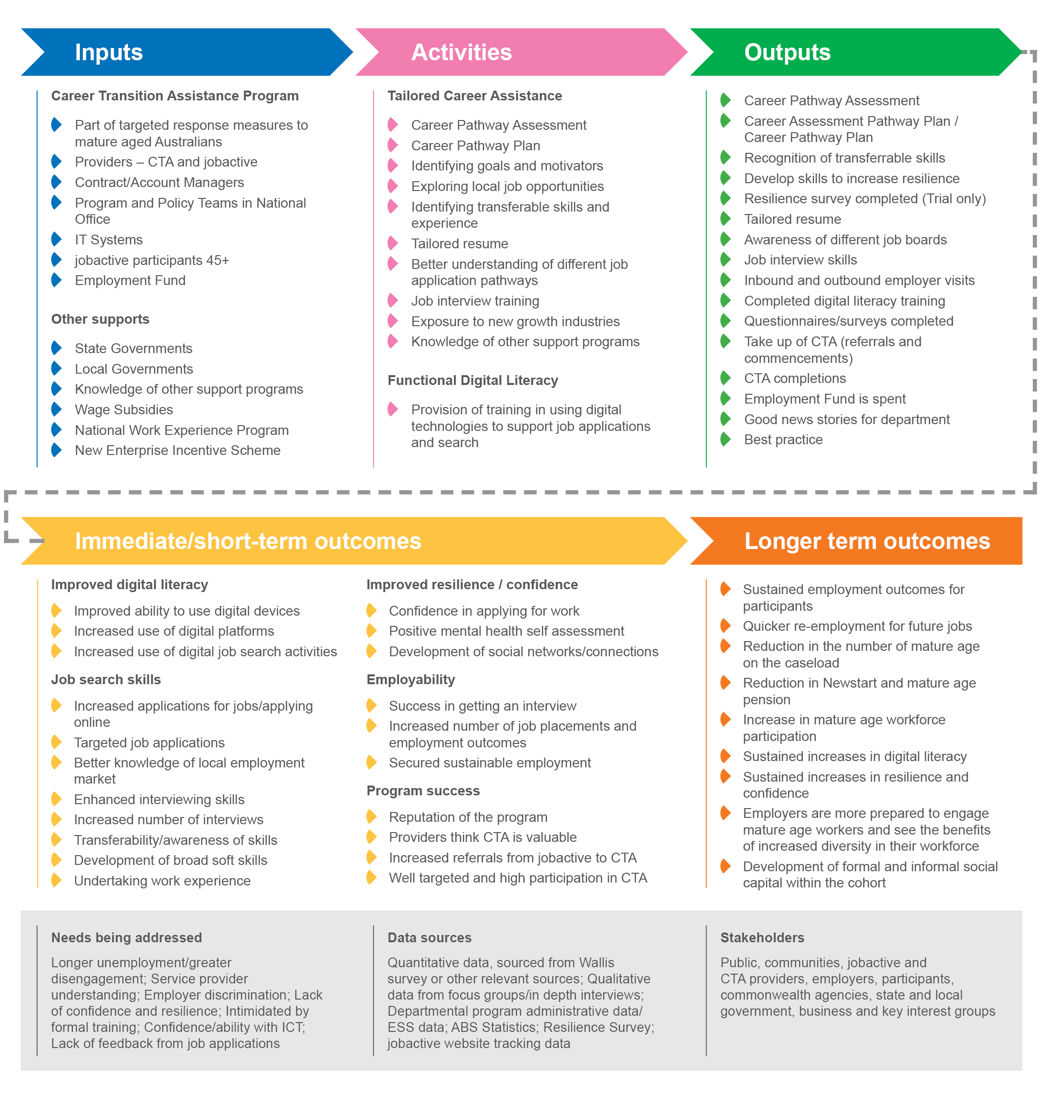

Figure 3 The CTA program: key areas of evaluation

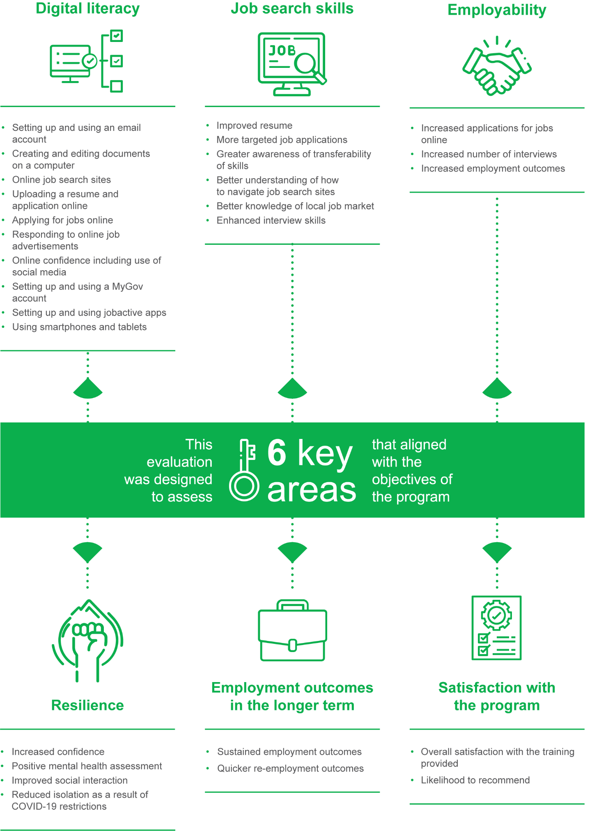

##### Human Capability

There is an important distinction between human capital and human capability.[14] Human capital can be thought of as all the knowledge, habits, and personal attributes that an employee uses to produce ‘economic value’ during their lifetime. In the context of the CTA program, we can think of human capital as the knowledge, habits and personal attributes that a person needs to get a job.

The CTA program clearly focuses on building human capital with the objective of achieving sustained employment outcomes for mature age job seekers. The program objectives of expanding knowledge relating to digital literacy, improving job search skills, and developing resilience to persist until a job outcome is achieved are all human capital capacities. They are essential for a mature age job seeker to successfully secure a job.

Human *capability*, on the other hand, is a concept that subsumes human capital and extends beyond a focus purely on economic productivity. In the context of the CTA program, human capability includes the contributions that an employee makes to the broader society throughout their life outside the work they do as an employee.

As this is a broadly defined concept, there are many views on how human capability should be measured, but common measures include a person’s wellbeing, health, strength of social relationships, resilience, and range of life options available.[15]

It is naturally the case that attainment of some of these capabilities can be regarded as the ‘currency’ of the attainment of human capital[16] mentioned above and therefore can be seen as a prerequisite for being employment ready.





While the CTA program necessarily focuses on building human capital, it also has a beneficial side effect of building human capability for the participants.

For instance, better digital literacy can be used by participants to engage more effectively with younger family members, who typically have higher levels of digital literacy. This more effective engagement can lead to a wide range of social benefits relating to improved social cohesion and a feeling of inclusiveness.

Many of the skills taught to create better job search outcomes are also directly applicable to other social situations; thinking about the transferability of skills can lead to other thoughts about broader social skills. Merely participating in a program that involves interaction with other people with similar employment issues leads to increased confidence which can have a positive impact both inside and outside the employment setting.

## Methodological overview

Figure 4 shows an overview of the steps in the research. Broadly, the research fieldwork consisted of a longitudinal survey of program participants, along with extensive one-on-one consultations and focus groups with participants and stakeholders. The various steps are described in more detail in the following sections.

Figure 4 Overall evaluation methodology flowchart

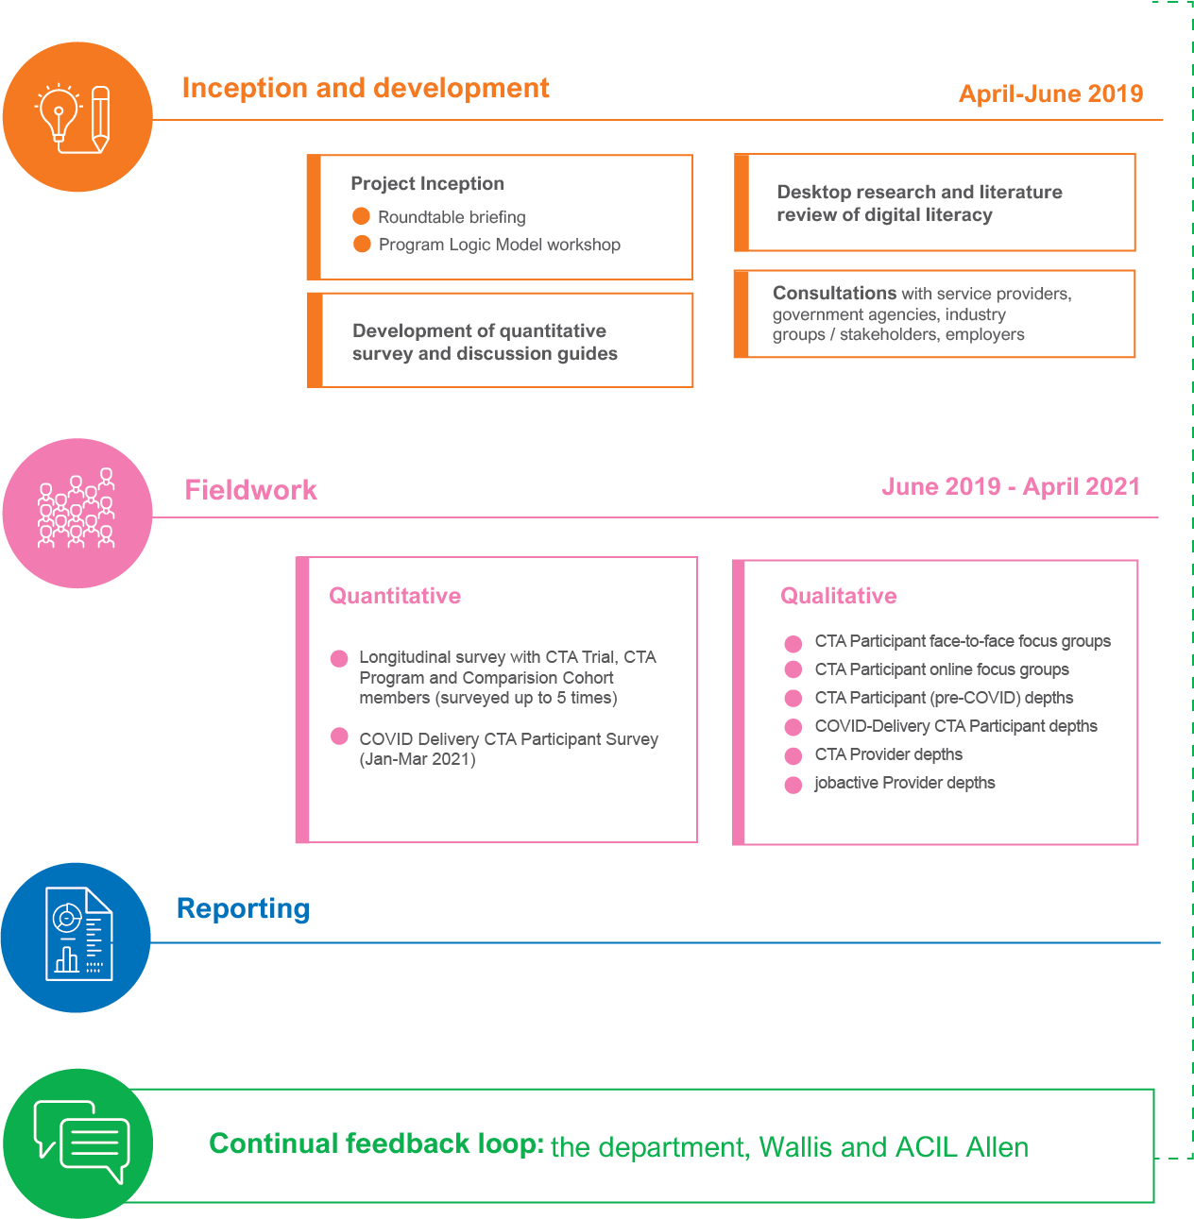

## Quantitative component

##### CTA Longitudinal Participant Survey

The quantitative component of this research was conducted by Wallis using Computer-Assisted Telephone Interviewing (CATI) between the end of June 2019 and April 2021. The survey instrument was developed in collaboration with the department, ensuring that all evaluation criteria were matched back to the Program Logic Model. The survey ran for 16 minutes on average.

The survey instrument was designed using a ‘streamed’ longitudinal approach, so that respondents were interviewed as soon as they completed their CTA training (Wave 1). After completing the Wave 1 survey, respondents were asked to provide their consent to be recontacted to participate in waves 2, 3 and 4. An additional group named the ‘comparison cohort’[17] was also surveyed longitudinally alongside the CTA program cohorts. This group consisted of job seekers with a similar demographic profile to those participating in the CTA program.

In December 2020, the original survey instrument was adjusted to allow for the extension of fieldwork to the end of March 2021. This extension allowed for additional Wave 4 respondents to be surveyed.

An additional Wave 5 was also incorporated into the evaluation so that some respondents (those who were involved in the earliest iterations of the CTA program) could be invited to participate 18 months after completion.

A new stream was created each month comprising the participants believed to have completed the CTA program each month. A comparison cohort group was also created each month. Data in this report has been aggregated across waves as follows:

* **Wave 1:** just completed the program
* **Wave 2:** 3 months after the program
* **Wave 3:** 9 months after the program
* **Wave 4:** 15 months after the program
* **Wave 5:** 18 months after the program.

This approach is represented graphically in Figure 5.

##### COVID delivery CTA participant survey

In January 2021, the COVID delivery CTA participant CATI survey was developed in collaboration with the department. The survey was designed so that participants who completed the CTA program during COVID-19 restrictions could provide their feedback on the delivery of the CTA program during this time, and track their outcomes since completing the program.

Fieldwork for this additional survey commenced on 14 January 2021 and concluded on 31 March 2021. Overall, 650 CTA ‘COVID delivery’ participants were surveyed across Australia, with the survey running for approximately 25 minutes on average.

Figure 5 Quantitative surveys methodology overview

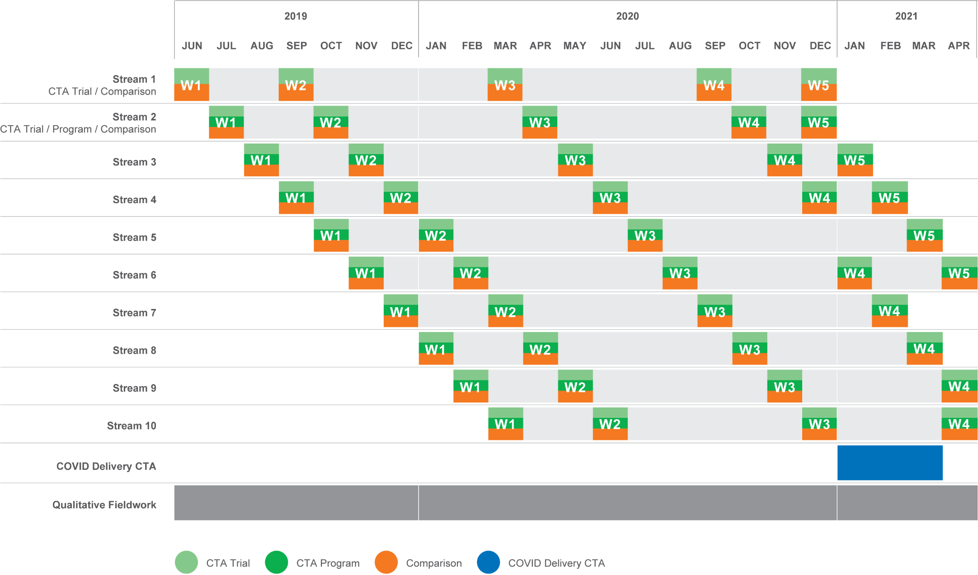

##### Sample

The sample for the CTA Longitudinal Participant Survey was provided by the department each month and was made up of CTA trial and CTA program participants. The sample included a number of variables, including the respondents’ commencement dates in the CTA program, their CTA and jobactive provider, country of birth, location, gender and length of unemployment (as recorded by the department’s administrative data).

A comparison cohort sample was also drawn each month to match the broader cohort of CTA participants. The sample of comparison cohort job seekers was drawn based on geography, age and gender. The purpose of the comparison cohort group was to gather responses to questions from a comparison cohort that was broadly similar to those responding as part of the CTA trial/program.

A total of 4,785 pre-COVID CTA participants and 3,931 COVID delivery CTA participants were approached to take part in the survey, with 2,275 completing at least one survey. Table 1 provides a summary of completed surveys by wave and survey cohort.

Table 1 Breakdown of survey completions

|  |  |  |  |  |  |  |
| --- | --- | --- | --- | --- | --- | --- |
| Survey | Wave 1 Completes | Wave 2 Completes | Wave 3 Completes | Wave 4 Completes | Wave 5 Completes | Total Completes |
|  | *(n=)* | *(n=)* | *(n=)* | *(n=)* | *(n=)* | *(n=)* |
| CTA Trial  Longitudinal Participant Survey | 174 | 122 | 78 | 59 | 40 | 473 |
| CTA Program  Longitudinal Participant Survey | 558 | 385 | 236 | 181 | 38 | 1,398 |
| Comparison Cohort  Longitudinal Survey | 893 | 540 | 284 | 178 | 49 | 1,944 |
| COVID Delivery  CTA Participant Survey | 650 | N/A | N/A | N/A | N/A | 650 |

##### Analysis of program administrative data and a lack of completion data

Where possible, the evaluation also sought to include administrative data in quantitative analyses. The administrative data in relation to the CTA program provides good coverage in terms of details on participant characteristics, but data on completion and employment outcomes is incomplete.

The current design of the program does not incentivise providers to record participant completions in the system, meaning that completion data in the system is not reliably provided and cannot be used to indicate progress through the program.

For this reason, this evaluation has not focused on completion rates and this report has placed a greater emphasis on the survey data and qualitative feedback collected throughout fieldwork, with a lesser use of administrative data.

## Qualitative component

As part of the qualitative component of this evaluation, Wallis and ACIL Allen Consulting conducted 9 face-to-face focus groups, 8 online focus groups and 126 in-depth interviews with job seekers, CTA participants, CTA providers and jobactive providers across Australia. Fieldwork was conducted over 20 months from August 2019 to April 2021.

A summary of the qualitative fieldwork conducted as part of this evaluation is provided in **Error! Reference source not found.**.

Figure 6 Summary of qualitative fieldwork



All qualitative fieldwork was moderated by Wallis and ACIL Allen senior staff members with extensive experience in eliciting responses from stakeholders and job seekers.



# Program delivery

The following section provides a summary of the characteristics of CTA participants derived from department CTA administrative data. The section also provides an overview of the CTA program delivery using the qualitative data collected during fieldwork.

## Activities and outputs

##### CTA participants

All job seekers aged 45 years and over who were registered with a jobactive provider, as well as volunteer job seekers, without mutual obligation requirements, were eligible to participate in the CTA program during the program evaluation time period.

During the evaluation, the CTA program was targeted at mature age job seekers who were long-term unemployed, with 58% of CTA participants being unemployed for more than 12 months (see **Error! Reference source not found.**).

Figure 7 Unemployment duration, CTA participants (1 July 2019 to 31 March 2021)

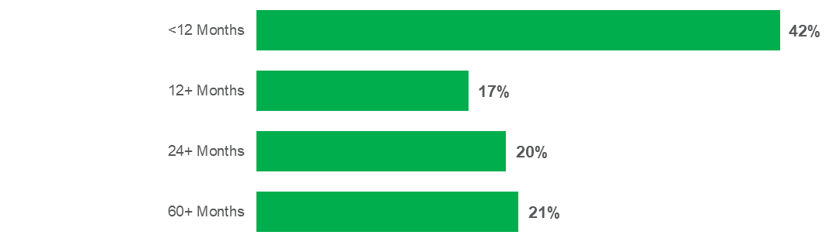

*Source: Department of Education, Skills and Employment (DESE), CTA administrative data.*

Despite the focus on disadvantaged job seekers, almost half of the participants in the CTA program from 1 July 2019 to 31 March 2021 were classified as ‘job ready’ (Stream A), at 44%, with 43% classified as having some barriers to employment (Stream B) and only 12% from the most disadvantaged group (Stream C). See Figure 8.

As at 31 December 2019, 16% of individuals in jobactive were classified as Stream C.[18] This would indicate that CTA participants, despite being long-term unemployed, were generally classified as being more ‘job ready’ than the average jobactive individual.

Figure 8 CTA participants by jobactive stream (1 July 2019 to 31 March 2021)

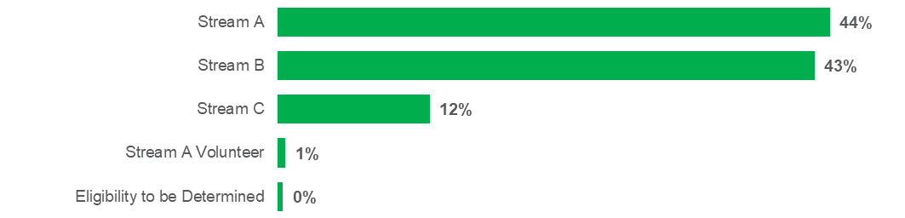

Source: DESE, CTA administrative data

As shown in Figure 9, the participants in the CTA program were quite diverse, with 23% from culturally and linguistically diverse (CALD) communities and 6% identifying as Aboriginal and/or Torres Strait Islander. In addition, many CTA participants had multiple barriers to employment, including 26% classified as people with a disability, 11% with mental health conditions and 6% dealing with drug and alcohol issues, and 6% of the participants were classified as homeless. Around 1 in 10 participants (11%) were in receipt of a parenting payment.

Figure 9 Characteristics of CTA participants (1 July 2019 to 31 March 2021)

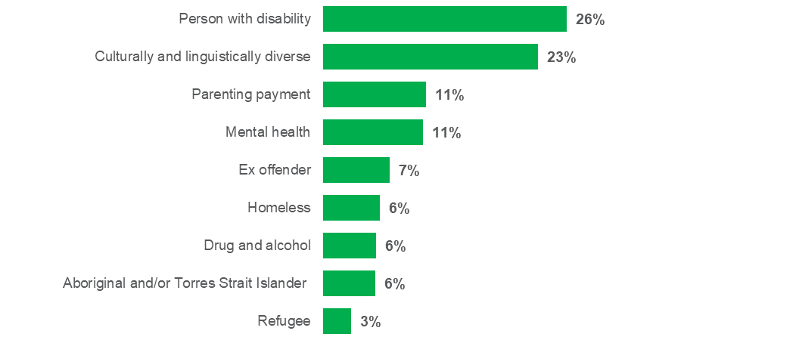

Source: DESE, CTA administrative data

##### Referral process

To participate in the CTA program a registered job seeker (97% of whom were receiving JobSeeker payments) had to be referred to CTA through their jobactive provider.

In the period from 1 July 2019 to 31 March 2021, 11,085 job seekers were referred to the CTA program and 75% (8,407) commenced the course. Due to the structure of provider reporting arrangements, detailed program monitoring data on course completions is not available. Of CTA participants surveyed as part of the evaluation, 71% reported completing the course.[19]

Some CTA providers are a stand-alone provider while others are also a jobactive provider. The program was originally designed with the expectation that CTA and jobactive providers would work closely together to ensure that those mature age job seekers who would most benefit from the CTA program were referred to the program. This was particularly important where a CTA provider was not a jobactive provider.

* I suppose the most challenging thing has been able to get the jobactives to understand the program and to then want to refer to the program.
* CTA provider in-depth interview

##### Program design

The CTA program was designed to achieve the following objectives for participants:

* increase motivation and resilience to look for work
* increase a participant’s awareness of their local labour market and the skills required to enter it
* support the identification of transferrable skills
* provide practical assistance with ICT and digital skills to build confidence and increase digital skills to help find a job and use in the workplace
* set clear goals and develop a pathway to achieve these goals.

While the department outlined the CTA program course components, CTA providers were encouraged to use innovative approaches in the delivery of the CTA program and significant flexibility was provided to allow CTA providers to structure and tailor the program to meet local needs. There were a limited number of compulsory course components including undertaking a Career Pathway Assessment at the initial meeting, facilitating outbound or inbound employer visits and arranging a ‘warm handover’ with the jobactive provider at the completion of the course.

The CTA provider would work with the participant to develop a Career Pathway Plan (based on the Career Pathway Assessment, which reviews their transferable skills, their work experience and their employment and other goals). Consideration was also given to their technical and digital literacy skills and any barriers they may face in obtaining employment.

The warm handover provided an opportunity for a meeting between the participant, the CTA provider and the jobactive provider to discuss what had been learned and the Career Pathway Plan. The Career Pathway Plan was also referred to at the completion of the course in a ‘warm handover’ meeting with the jobactive provider. This would highlight the CTA participant’s skills and employment goals and help map a pathway to employment.

##### Changes to CTA due to referrals

One of the early challenges faced by the CTA program was the lack of referrals by jobactive providers to independent and non-affiliated CTA providers.

The main reason for the low number of referrals identified through the CTA top-line early insights evaluation report was that the CTA program was originally funded through the Employment Fund General Account (Employment Fund) and jobactive providers were required to draw down on their Employment Fund allocation to fund participants in the CTA program. The Employment Fund is a pool of funds available to all jobactive providers to fund tailored supports such as training, licensing or the purchase of tools or services that will assist a job seeker to gain employment. Each jobactive provider received an allocation that they could use and seek reimbursement for the purchase of training, courses or goods and services.

Many jobactive providers were not prepared to pay the $1,800 to $2,250 required for the CTA program when they believed they could obtain a job outcome through funding a licence or ticket (such as the Prepare To Work Safely In The Construction Industry white card) for much less.

As a consequence, CTA providers associated with a jobactive provider were receiving almost all their referrals from their affiliated jobactive provider. Some providers stated that they had not received an external referral for over 10 months.

Independent and non-affiliated CTA providers found it difficult to engage with jobactive providers, in part because the CTA program is not compulsory. Therefore jobactive providers had a greater focus on meeting areas of compliance.

Given that the CTA program was in the early stages of development there was also a lack of information regarding the success of the program in obtaining sustainable employment outcomes for mature age job seekers.

The low level of referrals potentially impacted on the viability and sustainability of the CTA program. Some CTA providers ran just one course per month for 6 referrals and others had to reduce staffing to remain viable.

In response to feedback about the issues with the CTA program and the COVID-19 pandemic that begun in early 2020, the Australian Government provided the program with separate funding in place of the Employment Fund on 4 May 2020.

The change in the funding arrangements was well received by CTA providers and resulted in a significant increase in the number of referrals.

* (Because of the previous funding model) there was no real pressure on providers to refer and it's voluntary obviously. If they hadn't have changed it, the program would eventually fail, because there's only so many of your own clients you can refer.
* CTA program provider in-depth interview

CTA providers are still very reliant on internal referrals from an affiliated or owned jobactive provider. Between 1 July 2019 and 31 March 2021, 39.5% of all referrals to the CTA program were coming from their own or affiliated jobactive provider.

Even with the CTA program having separate funding, jobactive providers have indicated that they are still selective as to whom they refer to the program. This is to ensure they target participants who would benefit most from the CTA program and obtain a good outcome from the investment. The selection process sometimes includes strict vetting of applicants and preference for those applicants who:

* are looking for a change of career
* are motivated and able to commit to an 8-week program
* would benefit from the digital literacy training
* have a reasonable level of English.

##### Changes to CTA program as a result of COVID-19 restrictions

The CTA program became even more important for mature age job seekers during the COVID-19 restrictions, which resulted in changes to the labour market and increased use of digital technologies for work, shopping, service delivery and community engagement.

* The need for people to be online I think has really been emphasised in the last couple of months. Not just from a skilling point of view for work, just for life in general and maintaining contact with family and friends. For those people who are isolated who can’t use social media to keep in touch with their family or work, then they’re at a real disadvantage. Not just financially, but also from a mental health perspective.
* CTA provider in-depth interview

As a result of the introduction of COVID-19 restrictions in March 2020 the Australian Government required CTA providers to deliver the program remotely or to pause delivery if this was not possible.

CTA providers, in response, demonstrated great innovation in transitioning the CTA program to online and other forms of remote delivery. This included providing CTA participants with computers and devices preloaded with content and coaching them over the phone on how to use the device and access the content, to the use of web-based and teleconference options for delivery.

## Qualitative findings on CTA program delivery and structure

##### CTA program design

CTA providers who were consulted believed that the CTA program is well designed to meet the needs of mature age job seekers and that the structure of the program is sound. In particular the program:

* recognises the challenges of mature age job seekers over 45 years of age and fills a gap for this growing cohort of job seekers that was not able to be fully provided by jobactive providers because of their extensive caseload
* is well tailored to the needs of mature age job seekers with the use of group sessions to strengthen engagement and social interaction and course facilitators who tended to be of similar age. The facilitators could provide more intensive one-on-one support and offer a holistic approach to the training
* can help with important pre-employment skills and enhancement of human capability such as confidence, motivation, and a level of dignity which some CTA participants may feel they are lacking, given the challenges they face
* facilitates reconnection of mature age job seekers with the labour market and provides intensive support at a time/stage when disconnection (both from the labour market and socially, more broadly) can quickly become entrenched
* is well tailored to address the issues of structural adjustment in regional areas where there are thinner labour markets and a need for job seekers to recognise their transferrable skills so they can transition between sectors to secure employment
* provides a good combination of job search skills and digital literacy training which recognises the multiple barriers faced by mature age job seekers
* provides practical tools for mature age job seekers to combat ageism, sell themselves and avoid discrimination.
* I think this is one of [the] best programs of the department’s that I’ve ever encountered in the 10 years that I've been in [job services]. I think it’s intelligent. I think it recognises the challenges that the over-45s have. I think bringing it down to 45-year-olds was a good move, as opposed to when it was 50-year-olds.
* CTA program provider in-depth interview

Many CTA providers, including those who have been involved in the delivery of other employment programs, rate the CTA program very highly in terms of its design and its ability to address the needs of mature age job seekers. Significant benefits were identified in terms of building resilience and confidence and helping to motivate mature age job seekers.

* to see the change in people’s confidence, they begin to believe that they do have things to contribute, that there is a possibility of them obtaining a job, that this isn’t it, that they’re worthwhile. Seeing that shift for people was incredible.
* CTA COVID delivery provider in-depth interview

One of the most important benefits participants reported getting out of the CTA program is that their confidence increased.

* It’s all of that whole life-changing stuff, someone was able to RSVP to a wedding and it was the first time they had ever sent an email, but CTA taught them that … it’s just those really lovely things, but it’s also the mental health support that CTA has given. I think [that] was the most touching part during COVID.
* CTA COVID delivery provider in-depth interview
* I would say it’s given me more confidence. It’s made me feel that I could get another job. It’s given me skills to get that.
* CTA participant focus group
* I think from all of the courses, it was important to be involved and it is a beneficial experience.
* CTA participant in-depth interview

##### Importance of the group setting

A unique aspect of the CTA program is the delivery in group settings of between 10 and 15 people on average.

A number of participants expressed the view that the group setting was one of the best aspects of the CTA program.

Many mature age job seekers who have been unemployed for an extended period of time are socially isolated. The group settings provided camaraderie where CTA participants were able to support each other and realise that there were other people who were in a similar situation to their own. As a result, the group dynamic was important in providing mutual encouragement and support. The group settings also created a work-like atmosphere where participants were required to interact and were able to work in teams.

* Often they may be the only person of their friendship group that is unemployed at the moment. So being able to get people of the same age group just really helped for them to be in that same environment with people in their same situation from their same area and they start building friendships that way, and support groups.
* CTA COVID delivery provider in-depth interview

While the CTA program groups varied in size, most participants felt that the group was small enough to facilitate these positive aspects of group learning, together with allowing one-on-one attention from the facilitator.

The social benefits that CTA participants experienced were felt across the board.

* It helps when you [have] got others there to balance things off. It made me realise that plenty of people of our age are having difficulty and just finding ways to try and crack the nut.
* CTA participant focus group
* This type of program develops confidence and skills, but also gives them a social network and lessens the feeling that they’re on their own. I think it really is about that connection of having other people that you can relate to – that’s why it’s important that it’s a group setting.
* Departmental staff, state office

The intense focus on group time across the CTA program duration of 8 weeks was also identified as a key contributor to good outcomes by some participants and providers. The intense focus allowed bonds to form between group members and also with the facilitator. Participants said that the bonds which formed supported the delivery of course content and outcomes such as increases in confidence, motivation and self-worth.

* It was amazing … One day I overhead the group talking about a participant … telling another participant how the day before, that they’d had a real breakthrough, that this person was quite depressed and difficult to engage with and the group had made it their mission to get this person laughing and engaging and they were talking about how that had happened and how positive it was. This was a regular occurrence throughout the program.
* CTA trial provider in-depth interview

##### Facilitators

Many CTA participants commented positively on the role played by the facilitators and the fact that they often went over and beyond to address the concerns of participants.

Many of the facilitators employed by CTA providers came with a strong community services background and were of similar age to participants and were able to provide greater empathy and work with participants over an 8-week period.

* A successful facilitator has an approachable personality, someone that’s positive, someone that can easily motivate people … they have to be a people person because there’s all types of personalities in the classroom. People with all types of barriers. Someone with some worldly experience.
* CTA provider in-depth interview

Continued positive feedback was received about facilitators, who were valued in their role of providing support to CTA participants, both during and after the course. This support spanned 2 important domains: support as an expert in job search and digital literacy, and support in terms of providing motivation, encouragement and self-belief for participants. Importantly, the facilitators were not viewed so much as ‘classroom teachers’ but more as coaches and mentors. This was particularly important given the challenging position which many participants found themselves in, given that many had not needed to look for work, or consider career pathways, for some time.

* Looking back now, I can see he (the facilitator) was empowering us. He was always encouraging us. He was always saying things and I was thinking in my head, ‘I don’t really feel like that. I don't know how I could have any skills. I really don’t know this, I don’t know that.’ But looking back now, I can see that everything he did was encouraging.
* CTA participant focus group
* She (the facilitator) was fabulous, absolutely fabulous. Those people are saints, you get a variety of people all looking for work.
* CTA participant in-depth interview

The continuity of service, developed over daily sessions for a period of weeks, helps develop a group culture and allows CTA participants to develop a good rapport with the facilitator. Motivation and confidence are enhanced through this model as it allows the time required for group culture to form, and for individual participants to ‘let their guard down’.

##### Length of program

The CTA program is designed as an 8-week program that can be used to meet a job seeker’s mutual obligation requirements and will fully meet a job seeker’s Annual Activity Requirement during participation in CTA. A minimum of 75 hours of training is delivered under the program, with at least 50 hours of this in a group setting.

The general view of CTA providers was that the length of the course was about right and that a longer course may result in lower rates of completion.

* … we absolutely support the length of the program being the eight weeks different to all the other programs, and sort of courses that we deliver on … in that period of eight weeks, we can achieve a change of attitude and confidence.
* CTA provider in-depth interview

The views of participants regarding the length of the program, on the other hand, were mixed. Some participants, especially those with low digital literacy skills, wanted the opportunity to continue to refresh and practise their skills. Other participants were also keen to spend more time applying for actual jobs as part of the course.

##### Career Pathway Plan

The Career Pathway Assessment developed at the commencement of the CTA program was seen by many participants to be extremely valuable in identifying transferable skills and helping to highlight their personal attributes and strengths and set a clear direction and goals. This was particularly the case for job seekers who were looking to transition to new careers or change occupation from their existing sector to a new sector where they may have had little prior exposure.

* It is built into their Career Pathway Plan, that they might need to go on and do further courses or development in this area. So I don’t think that CTA is supposed to be the program that will address every single barrier but it certainly is that pathway ... With the journey to them addressing those barriers.
* CTA provider in-depth interview
* We went through what I had achieved on the course, where we said at the beginning, what I wanted to achieve and then we went through it at the end to see how much of that I had achieved.
* CTA participant in-depth interview
* I found it to be useful because it gave some structure and related bits and pieces. Putting data into it also made it tangible to your own self that, yes, these are my strengths, these are my weaknesses. This is what I could possibly be doing as an alternative to where I come from.
* CTA participant focus group

For other CTA participants, the Career Pathway Plan was not highly valued. This was especially the case for those participants who expressed the view that they were just looking for a job and were not looking for a new career.

##### Rolling enrolments

The fact that enrolment in the CTA program occurred in a ‘rolling’ fashion, whereby participants could join the group at any stage of the course, was raised as an issue by some participants and providers.

The rolling enrolments did not seem to be an issue for larger providers that had larger groups. For these providers, a rolling enrolment could be managed with less disruption to the groups. For providers with smaller groups, however, the rolling enrolment was seen as disruptive; participants joining at a later stage, having missed earlier content or with a very different skill level to other participants meant that facilitators had to provide assistance to allow new participants to catch up with the rest of the group. At the same time, for some of the smaller providers, rolling enrolment made the CTA program feasible. Therefore, they appreciated the level of flexibility that this approach afforded them, notwithstanding the challenges it created.

* The facilitator needs to engage all sorts of people at the same time because of the rolling starts. There’s new dynamics coming in every week or fortnight. So it’s a big challenge to keep everyone engaged and feel valued.
* CTA provider in-depth interview
* The one thing that I really think was wrong with the course, is that every week new people would come into the course, every Monday. Then the facilitator had to start from basics with them and we'd been through the basics so we were left to our own devices. I think that’s obviously a downfall because every week we would lose time while they were dealing with the new people.
* ****CTA participant in-depth interview

##### Voluntary nature of CTA

The voluntary nature of CTA was generally seen as a positive by CTA providers. Because the program is not compulsory, only individuals who were motivated to do the course participated, as opposed to participating in the course for compliance reasons.

* Don’t make it a mandatory thing that if you're over 45 and you’re not doing anything, you must do this course, because the beauty of this is that it’s voluntary. If you don’t want to be there, you don’t have to be there. And that just makes it so much easier to deliver.
* CTA provider in-depth interview

In contrast, a number of CTA providers expressed the view that the program was so effective that it should be made compulsory for all long-term unemployed mature age job seekers. It was suggested that the program could potentially have 2 tiers: a voluntary tier for most applicants; and a compulsory tier for certain cohorts who have been unemployed for an extended period of time and where it is believed the program would greatly assist.

* I think when you get to a certain age and a certain length of unemployment, it should be compulsory.
* jobactive provider in-depth interview

From a participant perspective, not all were aware that the program was voluntary. Rather, they had effectively complied with and accepted what the provider had told them to do.

However, the fact that some participants were initially sceptical but ultimately supportive of the program suggests that there may be a place for a firmer adoption of CTA in cases where participants do not immediately see its value. For example, some participants in the CTA program had concerns about the terminology used, with its references to a ‘career’ and ‘pathway’, which have connotations of progress and advancement. The sentiment expressed by these participants was that they ‘wanted a job, not a career’. Nevertheless, some participants who originally held such a view did engage with the program and ultimately benefited from considering their career and potential pathways.

##### Metro versus regional delivery

The delivery of the CTA program in some smaller regional communities was challenging for 3 reasons. First, smaller regional communities have more limited job opportunities than larger population centres. Second, the smaller class sizes made the commercial sustainability of the CTA program more challenging. Third, the travel costs and time required for participants to attend the programs presented a barrier; there were isolated reports of some participants who needed to travel up to 3 hours per day to participate.

The delivery of the course online during the COVID-19 restrictions allowed regional providers to increase their reach and lower the costs of participation for many participants.

* By being able to do remotely, we were able to offer to clients in [REGIONAL TOWN], which was good actually ... Normally their clients wouldn't get the opportunity to attend the face to face CTA, because it just wasn’t one of the places that we were contracted to provide it to. Definitely were able to reach more people.
* CTA COVID delivery provider 2

A number of jobactive providers indicated that the switch to online delivery during the COVID-19 restrictions allowed them to make more referrals because services could be offered in regional areas which were previously unsuitable because of long travel time. In addition, in some regional areas, trainers were not available to deliver the training. In these cases, online delivery enabled a broader reach and opportunity to increase participation.

##### Engaging with employers

Industry engagement involving both outbound site visits to employers and inbound visits by employers was a challenge for CTA providers.

A number of CTA providers focused on facilitating inbound visits by employers. These were found to be easier to organise and they avoided the insurance, liability and occupational health and safety issues that some employers face when hosting groups on site.

* It’s a risk with insurance. There’s a lot of compliance, with regards to that.
* CTA trial provider in-depth interview

Where there was industry engagement from a diverse range of employers it was well received by CTA participants. There were even instances reported where a participant changed career direction or secured employment as a direct outcome of a site visit.

* We have great relationships with industry groups. We have thousands of employers and industry groups that we work with. Many of them are invested in supporting not just CTA but all their programs and come and do guest speaking with us, come and do our programs and allow us to do outbound industry awareness experiences with them also.
* CTA trial provider in-depth interview

CTA participants expressed the view that they would like to hear more from people in industry or recruitment agencies to hear first-hand what their industry sector is really looking for.

The more flexible delivery models adopted during the COVID-19 restrictions allowed for innovative approaches to engage with employers. Examples included facilitation of virtual site visits and guest speaker presentations via teleconferencing. One CTA provider used YouTube to provide ‘site visits’ and guest speaker type appearances to their nationwide network of CTA providers and participants.

* I have two regular employers and they both joined via Zoom and delivered as they used to in person, and just shared their screen with their PowerPoint presentations. We bring employers in rather than take (participants) out. So, those presenters will give an overview of their sites, and so forth, when they’re doing their presentations, rather than it being us taking (participants) out.
* CTA COVID delivery provider in-depth interview
* We had employers who would go to where our facilitators were and would run a Zoom session on employment in their industry, or what they're looking for when they're interviewing. The other thing we did as well was we actually got a series of employers and they came in and we actually videoed them, so then we could play that video to our participants at any time.
* CTA COVID delivery provider in-depth interview

Employers were positive that these kinds of approaches enabled at least some employer engagement to occur, and considerably reduced the administration involved, but did not tend to elaborate on how effective they were relative to on-site visits. Participants, too, tended to appreciate employer engagement in whatever form it occurred. However, a small number voiced the opinion that speaking with an actual employer may have been preferable.

* We didn’t visit any employers at their workplace but we watched about eight video recordings, and they were of employers telling potential employees what they were looking for in people ... and I think it might’ve been more valuable if we had a person that we could’ve asked questions to.
* CTA participant in-depth interview

##### The importance of health and wellbeing aspects

A number of CTA and jobactive providers highlighted the importance of health and wellbeing information and support in assisting jobseekers, especially mature age jobseekers. Many of the CTA participants are long-term unemployed and as a consequence may suffer from lower levels of confidence and self-esteem arising from the challenges of job seeking. This could result in heightened anxiety or depression among some job seekers.

Previous studies have identified a range of issues which could potentially impact on the mental health and wellbeing of job seekers.[20] These include:

* the loss or weakening of traditional economic or social structures for job seekers related to their employment
* increased family pressures arising from changing family relationships
* financial stress arising from lower family income
* reduced sense of identity arising from the loss of employment
* an increase in gambling and alcohol or drug related issues
* reduced self-esteem and confidence through unemployment and unsuccessful job search.

While it is recognised that CTA providers are not qualified health professionals, a number of providers highlighted the importance of health and wellbeing information and support in assisting job seekers, especially mature age job seekers. One provider believed that around a third of the class were facing mental health issues possibly arising from either low self-esteem, anxiety or depression. Another also noted significant mental health issues and believed they were common in women, with some coming from abusive relationships and working to rebuild confidence and get their life back on track by participating in the CTA program.

* Mental health, money/transport, and confidence in general … Look if you lose a job, you’re 45, on your own possibly, you lose contacts and you lose getting into a rhythm of communicating with peers and you sort of get into isolation, and et cetera. So it can go downhill pretty quick …
* CTA provider in-depth interview
* There is an increasing level of … mental health issues with participants whether that be depression, anxiety, panic attacks, or more serious conditions ... And that’s something that as facilitators, that’s not part of our remit. Really, that’s not part of our skill set to deal with that effectively. Certainly, what we do is we pair them back to their jobactive or suggest the basic medical attention.
* CTA provider in-depth interview

Another CTA provider noted that, based on their observations, CTA participants appeared to have more health issues than job seekers generally, including mental health and physical restrictions. They noted that the most significant factor cited for non-completion of the course among their participants was ill health.

In response to these challenges, some CTA providers incorporated some content on health and wellbeing into their program (even if they may not have labelled them as such), predominantly with a focus on building confidence and self-esteem and getting participants in a stronger headspace to better survive the challenges of job seeking.

Noting that it may not always be appropriate to deliver health and wellbeing support for participants within the CTA program, it could be beneficial to increase training and recognition of these issues, as well as the ability of program facilitators to refer to a range of services that could be made available to participants. Employment programs for retrenched workers delivered as part of the closure of the automotive manufacturing sector in Australia have some good practice examples that could be considered for the CTA program, subject to resourcing. These could include:

* openly discussing mental health and encouraging job seekers to monitor their mental health and wellbeing and to access support if needed
* referring or providing access to counselling and health and wellbeing support services available in their communities. These services could include those specific to job seekers, or more general services relating to mental health, general health, diet and exercise, housing, language literacy and numeracy, and drug and alcohol dependence
* providing training to participants and facilitators on wellbeing and resilience, to help equip them with the knowledge and tools to support themselves and others during job search
* following up with CTA participants at regular intervals post course completion.

##### Warm handover and transition

The warm handover between the CTA provider and jobactive provider at the end of the program was potentially an important aspect of the CTA program. It was designed to ensure there was ongoing support for the participant and guidance for the jobactive provider on further actions.

* … the response from the participants that I've had and even from the jobactives that I visited is to do warm hand overs has been good. I think they have been pleasantly surprised.
* CTA provider in-depth interview

The reported effectiveness of the warm handover process was varied. Some participants felt it was too brief or not sufficiently formal. Other participants felt that the in-depth of thinking and distance travelled as part of the CTA program was not sufficiently captured as part of this process.

A number of jobactive providers indicated that the warm handover, if done well, could be extremely valuable. However, in many instances, it was treated as more of a compliance obligation. Features of an effective warm handover included:

* communicating the Career Pathway Plan with the employment consultant, with a focus on the goals that the job seeker had identified
* taking early steps to build on and implement the Career Pathway Plan, which may include:
  + discussing transferrable skills
  + identifying training or other needs and gaps
  + discussing any barriers that a job seeker may face and appropriate strategies to overcome these barriers
  + following through on the recommendations and actions identified in the plan.

jobactive providers indicated that CTA participants were generally more motivated and confident after finishing the CTA course. Therefore, they said, it was important to keep that momentum going and follow through on recommendations and actions as quickly as possible after the program was completed.

The feedback regarding momentum points to a broader challenge with the CTA program: how should an appropriate and sustainable level of ongoing care and support be provided to participants? Some participants noted that they were disappointed with the level of service from their jobactive provider after completing CTA, though this is perhaps due to the fact that these participants had moved from an intensely supported intervention back to a more general level of support.

Some groups of participants formed bonds and stayed in contact with each other after completing the program. They provided mutual ongoing support to one another, sometimes with the involvement of the facilitator. This would appear to be a model which has some promise, although ongoing involvement of facilitators may raise questions of financial viability.

* We often still have participants coming in and catching up with the facilitator, letting them know what they’ve been up to. So we had one recently, she actually was going through chemotherapy while she was doing the CTA course and she came back to show the facilitator how much her hair had grown, how she was still looking for a job.
* CTA provider in-depth interview

##### Department’s role

CTA providers were complimentary of the role the department played in the original design of the CTA program and the way that it allowed flexibility for providers to tailor the program to local needs and introduce innovative approaches.

CTA providers appreciated that the guidelines and contractual documentation have been kept simple with clear explanations. This allowed them to concentrate on delivery rather than administration and reporting on compliance.

While there were some concerns regarding the level of marketing and promotion of the program in the early stages of the rollout, this has reportedly improved as the program has evolved, particularly through the use of case studies highlighting the success of the program.

* I think the department have been supportive in the implementation and the rollout. I do believe though that a lot of the jobactives have missed out on education for CTA. So I don’t believe there’s been enough education on CTA to the jobactives.
* CTA provider in-depth interview
* Process of referrals is marketing and that sales marketing with the jobactive providers. So, that would be the first step there. Just working really well with the jobactive providers, and educating them and pretty much promoting their program, not only for us, but for the department as well.
* CTA provider in-depth interview

The responsiveness of the department to addressing issues and refining the program was well received. In particular, CTA providers appreciated that issues experienced with the early low level of referrals (arising from the use of the Employment Fund) were addressed. The responsiveness and support provided by departmental state-based staff was also highly valued.

Given the program is voluntary, jobactive providers had discretion regarding whether they made a referral to the CTA program or used other interventions. The department played an important role in helping to promote the CTA program and encouraging jobactive providers to make referrals to the program.

|  |  |
| --- | --- |
|  | **Potential improvements**   * Continued and greater promotion of the benefits and case studies of the CTA program * Given the significance of health and wellbeing issues, consider incorporating modules on health and wellbeing in the program * Provide greater visibility to CTA providers on employment outcomes and feedback from jobactive providers after the ‘warm handover’ * Better enforce the effective delivery of the warm handover and ensure that jobactive providers follow up actions in the Career Pathway Plan * Allow the use of blended or online delivery in regional areas, or for particular cohorts of participants, to help reduce the costs of and barriers to participation and broaden the reach of the program * Continue to encourage jobactive providers to make referrals to the CTA program |

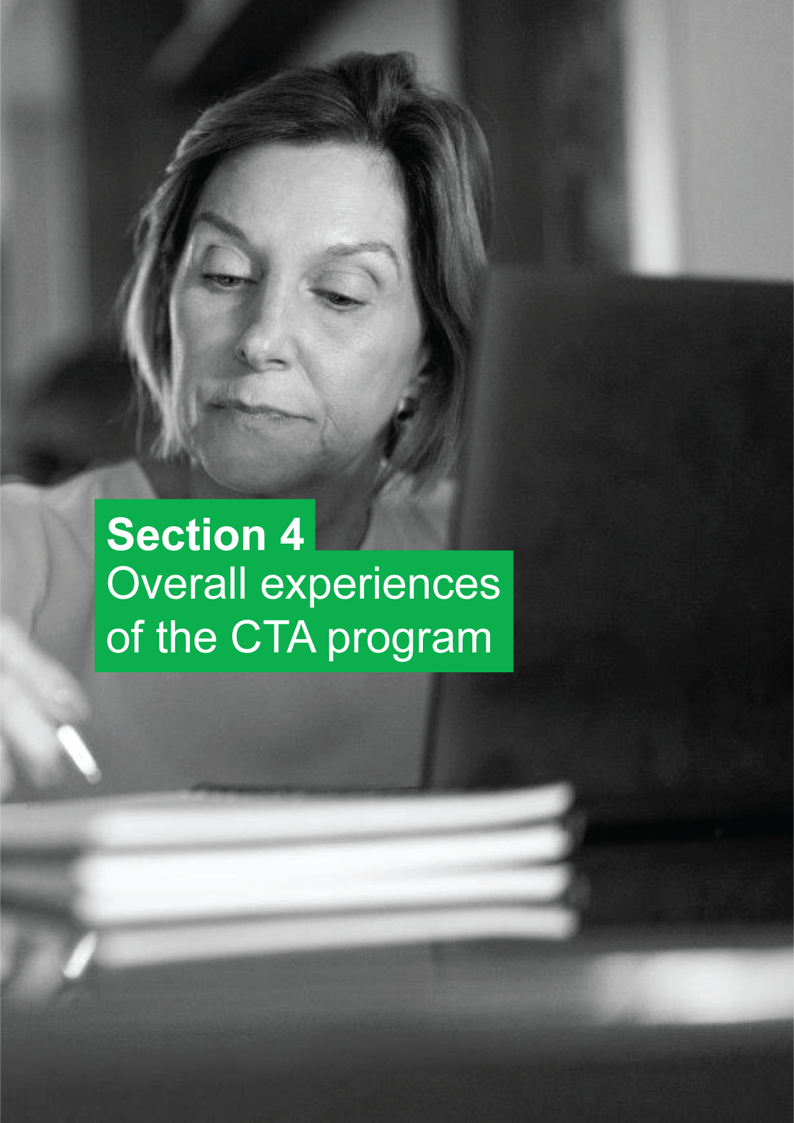

# Overall experiences of the CTA program

The following section describes the content of the CTA program as it was experienced by those in the trial and program cohorts, and participants’ overall assessment of the program. It also describes the experiences of those who undertook the CTA program during the COVID-19 restrictions, when delivery models were changed to account for restrictions which arose in relation to the COVID-19 pandemic.

## Overall participant perceptions of the CTA program

Figure 10 shows that participants in the CTA program rated it highly overall. On a scale from zero to 10, mean ratings of satisfaction were 8.3 for the CTA trial (based on 174 participants) and 8.4 for the CTA program (from 558 participants). For CTA delivered during the COVID-19 restrictions, mean satisfaction was slightly lower at 8.2 (from 650 participants). Similarly high ratings can be observed on the question of whether CTA participants would recommend the program to another person in their situation.

Figure 10 Mean satisfaction and likelihood to recommend ratings – across CTA program types

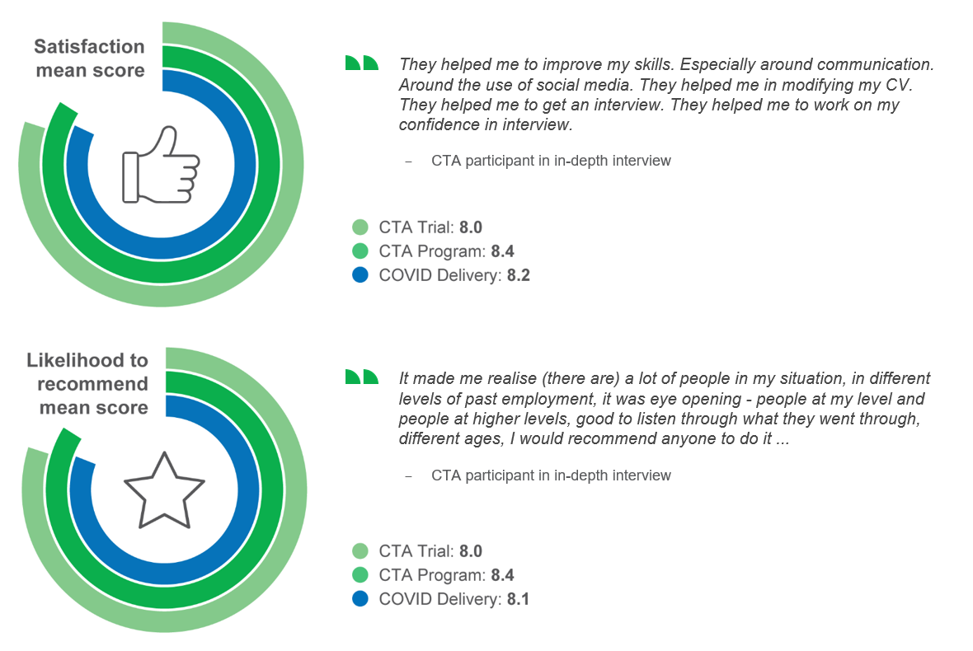

EV8: Overall, on a scale of 0 to 10, how satisfied are you with the training provided by <CTAPROVIDER>?

EV9: Overall, on a scale of 0 to 10, how likely would you be to recommend the training provided by <CTAPROVIDER> to another person in your situation?

Base: Wave 1 Group 1 and Group 2 trial/program respondents (trial n=174, program n=558); all CTA COVID delivery respondents (650)

Likelihood to recommend was often mentioned by participants during the qualitative fieldwork. Many participants saw the positive aspects of how the course could assist people who were in a similar situation to them.

* “Where have you been?’ I said ‘I did a CTA course.’ And they said, ‘What’s that?’ And I said, ‘It’s a Career Transition Assistance program that helps you to go on to the computer, do job searching and be approached by employers, and how to act, and dress, and computer shortcuts.’ The main thing I suggest is I recommend to join it.
* CTA participant in-depth interview
* Knowing that you're not alone out there, at that age. Knowing that there is help if you need it. There's probably things out there that we don't even know, and this course sort of opened up a whole world of things out there. So yeah, I would recommend someone that was over 45 do this.
* CTA participant in-depth interview

## Program components

At the time of the trial, the CTA program had 2 components: Functional Digital Literacy and Tailored Career Assistance. Participants in the trial experienced a mix of these components. The majority (58%) of trial participants experienced both components. However, just under a third (31%) of trial participants only experienced the Tailored Career Assistance component, while a little under a tenth (8%) only experienced the Functional Digital Literacy component.

Given that around a third of trial participants did not experience the Functional Digital Literacy component of the CTA program, it is unsurprising that trial participants reported being less likely to have experienced the individual digital literacy activities, as shown in Figure 11. The largest difference is for ‘Setting up a myGov account’, where 84% of CTA participants reported doing this activity, but only 71% of trial participants.

Figure 11 Activities or topics covered – as part of Functional Digital Literacy

Job search activities
Finding out about different online sites to look for jobs: Trial 87%, Program 97%
Editing and uploading a resume or a response to selection : Trial 91%, Program 95%
Applying for jobs online, including how to use the Jobactive website: Trial 87%, Program 94%
Responding to online employment advertisements: Trial 87%, Program 94%
Setting up and using an email account to apply for jobs: Trial 80%, Program 88%
Setting up and using Jobactive provider apps: Trial 74%, Program 83%
Broad digital skills
Getting online and using general search tools, including via social media: Trial 85%, Program 91%
Creating and editing documents: Trial 88%, Program 90%
Setting up and using a MyGov account: Trial 71%, Program 84%
Using smartphones and tablets: Trial 65%, Program 75%

EX2: Some of the training with <CTAPROVIDER> covered various areas of digital literacy. Can you please let me know which of the following activities or topics were included as part of your training with <CTAPROVIDER>?

Base: Trial and program Group 1 and Group 2 respondents (trial n=155, program n=558)

Given that over 90% of trial participants experienced the Tailored Career Assistance component of the program, there are very few differences between CTA participants and trial participants in terms of likelihood of having experienced activities related to finding work. However, there were a small number of noticeable differences, as can be seen in Figure 12. These differences mostly related to interaction with an employer. In particular, CTA participants (64%) were far more likely than trial participants (35%) to have had an employer come and speak with the group.

Furthermore, regardless of whether the participant was in the CTA program or the trial, activities involving interaction with an employer were much less likely to have taken place than any of the other activities the survey asked about. For example, only around a third of all participants (37% for CTA program, 31% for CTA trial) attended a visit to an employer.

In the in-depth interviews, many CTA participants mentioned that while they largely enjoyed and valued the program, they were disappointed to miss out on experiencing a visit from/to an employer, which was a visit they had been expecting.

* I've always thought that that [employer engagement] should have been an absolute focal, crucial point. I would have brought in people from industry, employers, to do mock interviews, and practice… there were no employers brought in at all to speak to the group, or nothing like that … it was talked about, but it never happened.
* CTA participant in-depth interview
* I think because I didn’t get to speak to either employers or employment groups … that seemed to be a stumbling block getting those sort of people involved. As I say, lots of promises, but unfortunately that was the big aspect that couldn't be delivered on.
* CTA participant in-depth interview

Figure 12 Activities and topics covered – Tailored Career Assistance

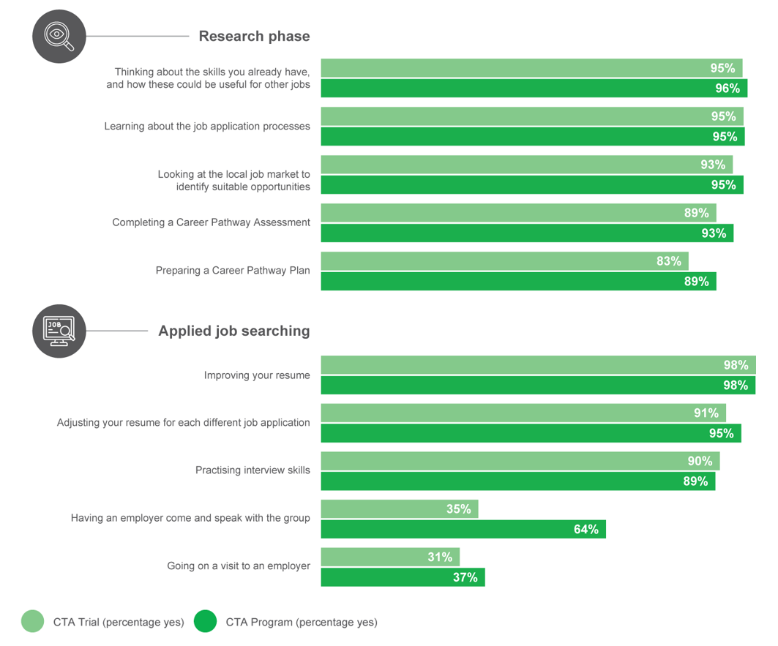

EX3: Some of the training with <CTAPROVIDER> covered topics which might help you find work. Please can you let me know which of the following activities or topics were included as part of your training with <CTAPROVIDER>?

Base: Trial and program Group 1 and Group 2 respondents (trial n=169, program n=558)

## Program delivery during COVID-19 restrictions

The COVID-19 pandemic seriously impacted Australia and most of the world during 2020. The most significant social distancing measures were implemented in Australia from March 2020. These social distancing measures necessitated a change in the delivery format of the CTA program.

In order to better understand the delivery of CTA during the COVID-19 restrictions, an additional survey was undertaken among those who had participated in the program during January–December 2020. It should be noted, of course, that differing levels of restrictions were in place across different states and territories, and at different times during this period.

During the COVID-19 restrictions, most (79%) participants experienced remote-only delivery of the program. Delivery entirely in person was only experienced by a minority (15%) and even fewer experienced a mixed format (7%). See Figure 13.

Figure 13 Delivery format experienced during COVID

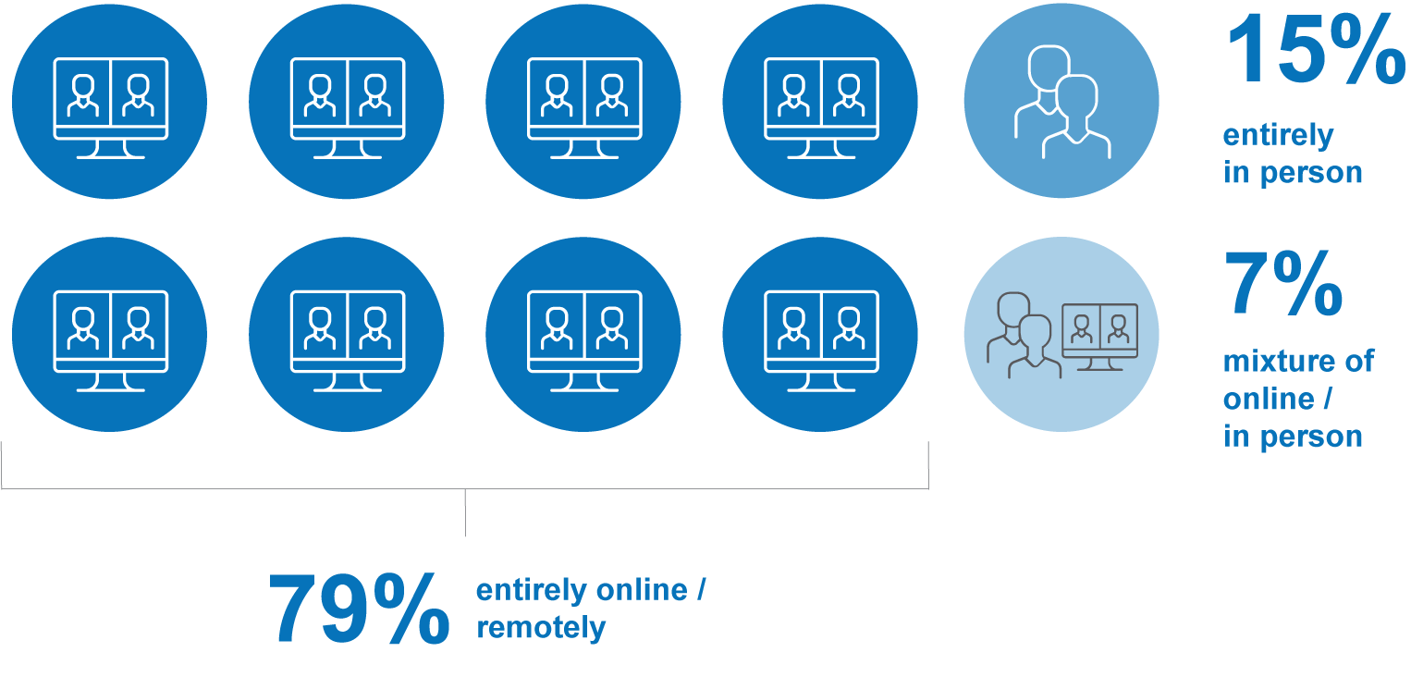

HY1: Can you please let me know how the CTA training you participated in was delivered?

Base: All CTA COVID delivery respondents (n=650)

During the COVID-19 restrictions, various delivery methods were used in combination. As shown in Figure 14, videoconferencing (78%) and email (79%) were the most commonly used delivery methods. Non-online methods were still widely used, including telephone or teleconferences (48%) and even posted materials, although that was less typically used (24%).

Figure 14 Delivery formats accessed during COVID delivery CTA

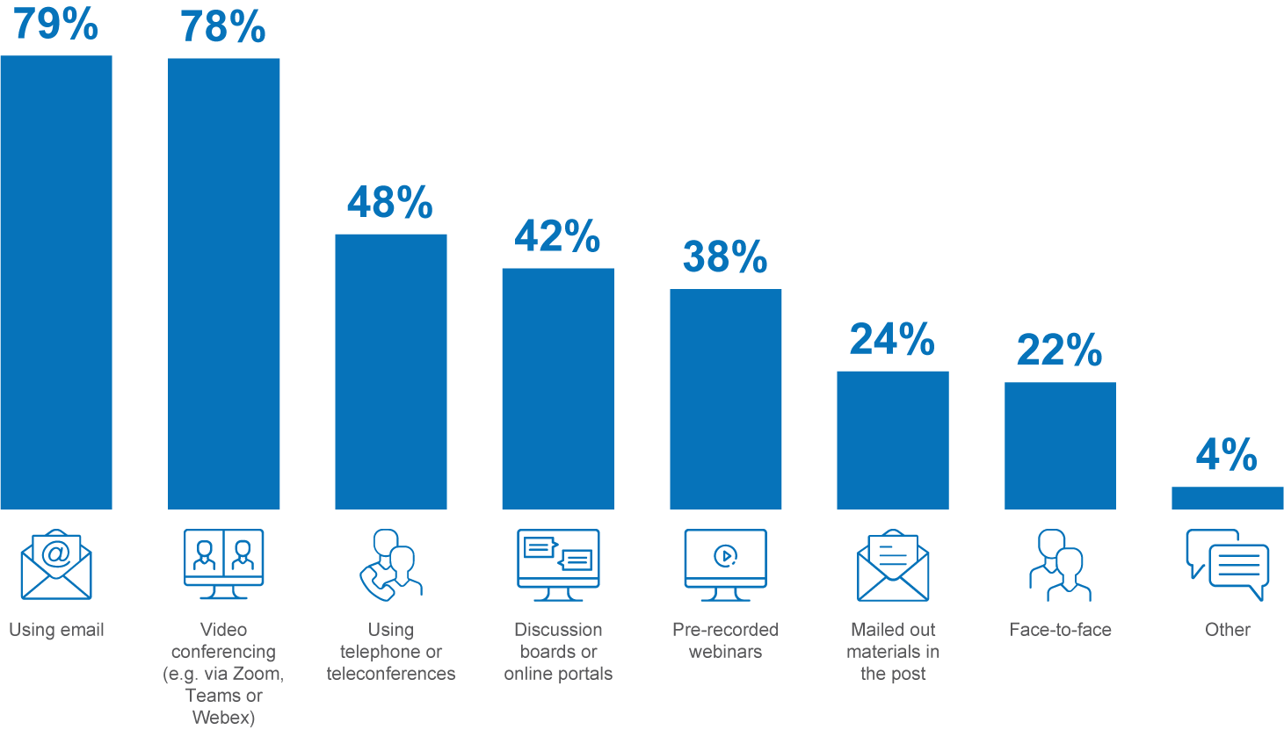

HY2: Which of the following delivery formats were included as part of your CTA course?

Base: All CTA COVID delivery respondents (n=650)

Figure 15 provides quotes from participants relating to the various delivery formats experienced during the COVID-19 restrictions.

Figure Selected participant quotes on delivery formats

Quote: The webinars and the presentations online that were provided were good.
Quote: She'd just phone out of the session. When she'd have time, she'd phone ... Just sort of as required. It wasn’t on a daily [basis] but maybe a couple of times a week. 
Quote: I've spoken to a few who obviously have reasonable levels of digital literacy skills and they're doing it via Zoom and other teleconferencing forms … it’s a good thing … being able to be delivered depending where people are at on their level of digital literacy.
Quote: It was a little bit of a shock doing it all online.
Quote: I appreciated the fact I had a workbook … (it) covered things and also directed me to look things up, so the written stuff was professionally done.
Quote: I could work at my own pace yet still have a deadline I could keep up with. I was emailed work and if I had trouble with it, I was able to contact the teacher and he would take me through it.
Quote: Zoom was handy, now I can also use on a personal basis.
Quote: The paperwork, I couldn't have followed instructions they sent out to me without person on Zoom explaining, it was hard to understand.

Figure 16 displays the frequency of and satisfaction with various combinations of delivery methods. The most frequent combinations included email, videoconferencing, and often telephone or teleconferences and/or online discussion boards. Posted materials were typically not included among the most frequent combinations of delivery methods. One of the key messages from this chart is the great variety of delivery combinations that were employed as part of the rapidly rolled out delivery methods during the COVID-19 restrictions.

Figure 16 Frequency of, and satisfaction with, combinations of delivery methods

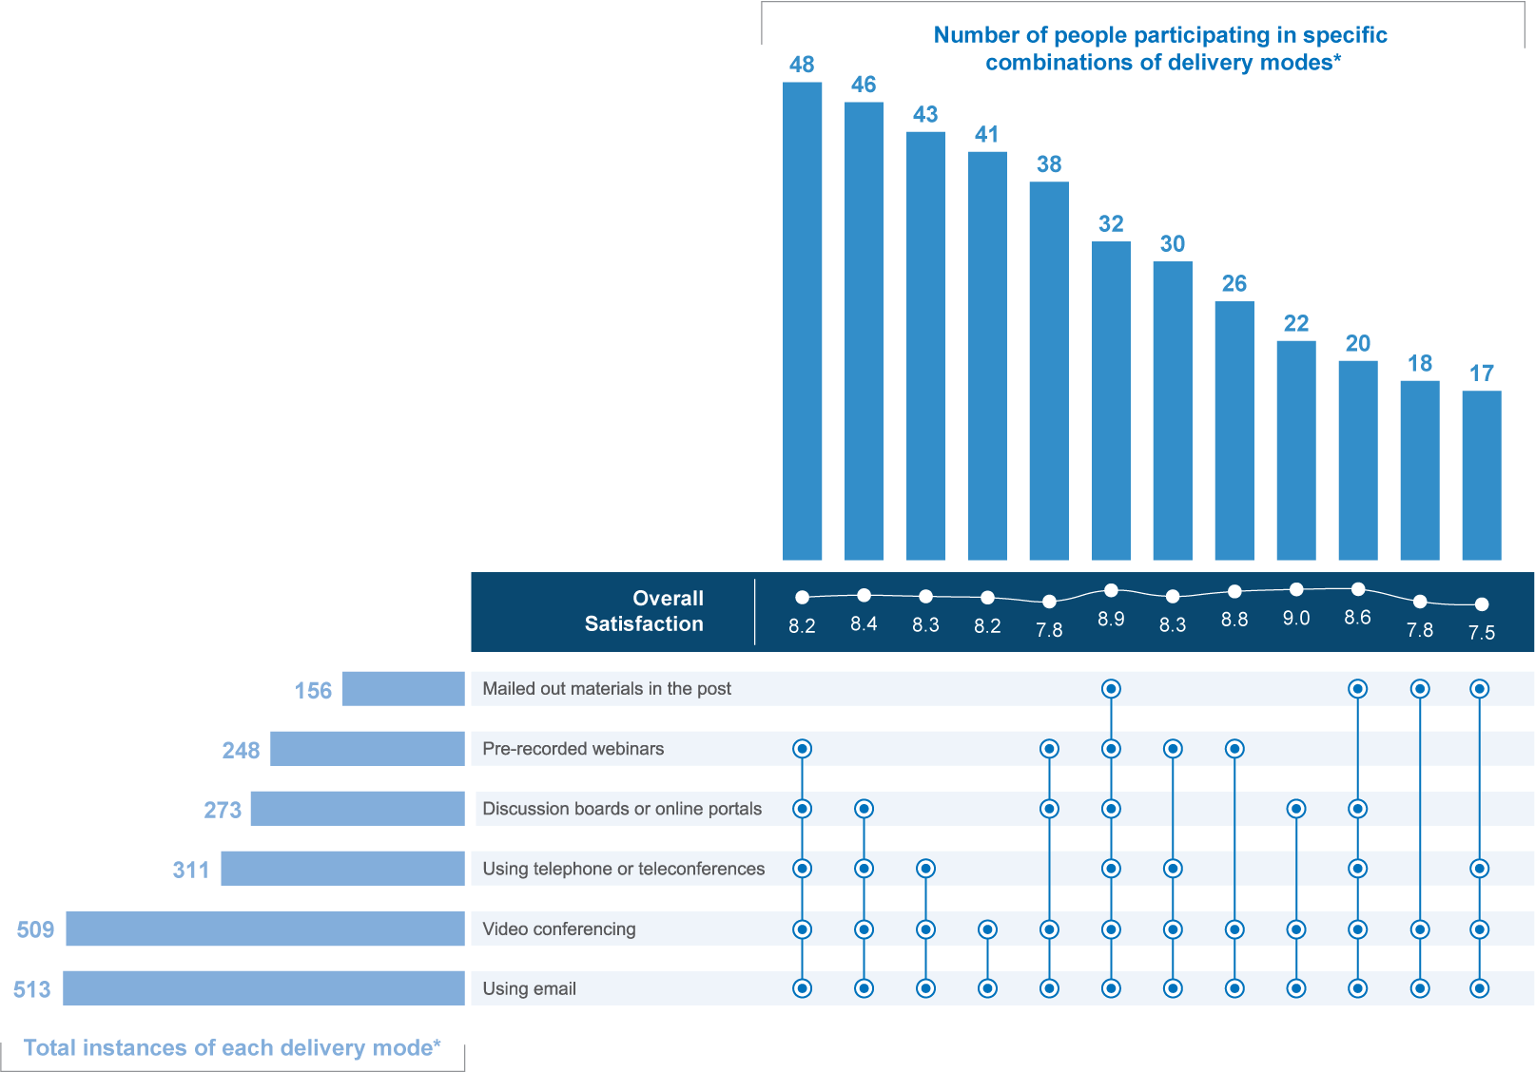

* These are raw numbers.

HY2: Which of the following delivery formats were included as part of your CTA course?

EV8: Overall, on a scale of 0 to 10, where 0 is totally dissatisfied and 10 is extremely satisfied, how satisfied are you with the training provided by <CTAPROVIDER>?

Base: All CTA COVID delivery respondents (n=650)

Note: Figures in this chart are based on raw figures rather than weighted figures.



# Outcomes

## Digital literacy among participants immediately post-program

In terms of experience with difference device types, there was little difference between groups (see Figure 17). Just under half of all survey participants had daily experience with a desktop or laptop computer. Just over a fifth had everyday experience with a tablet. However, the device that the highest proportion of survey participants had experience with was a smartphone with internet access, with at least 7 in 10 having at least daily experience with such a device.

* Tablets and smartphones and things are so integrated into daily lives these days but being on a computer or laptop is quite different.
* CTA participant focus group

Figure 17 Percentage using digital devices daily or more often

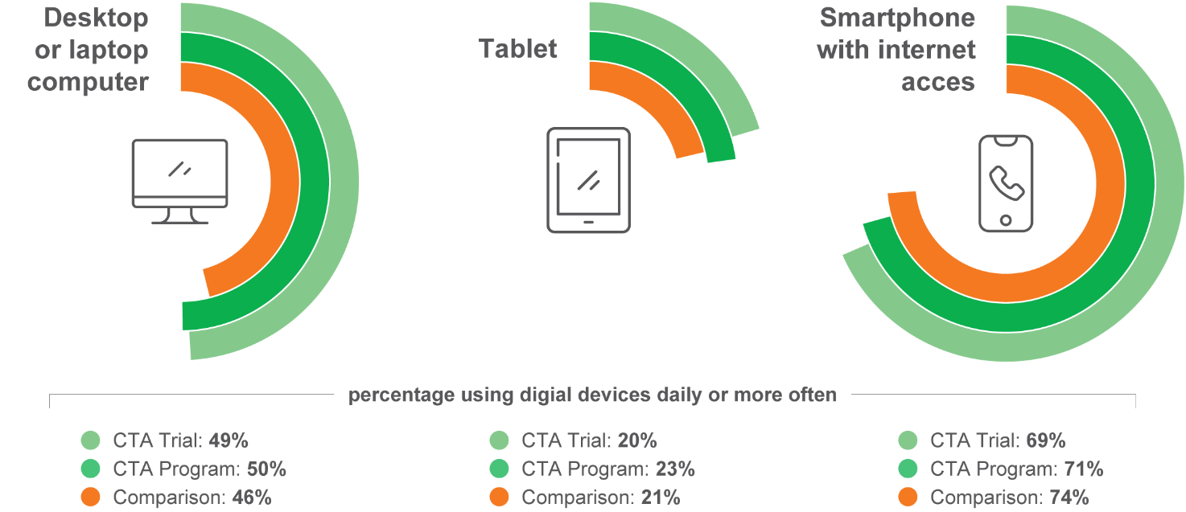

DA1a: Frequency – Desktop or laptop computer

Base: Trial/program/comparison Wave1 respondents (trial n=174, program n=558, comparison n=893)

CTA program participants were more likely to be confident than the comparison group with using digital technology. As shown in Figure 18, around 8 in 10 CTA participants were confident, while only around two-thirds of the comparison group were confident in using digital technology.

Figure 18 Confidence in using digital technology

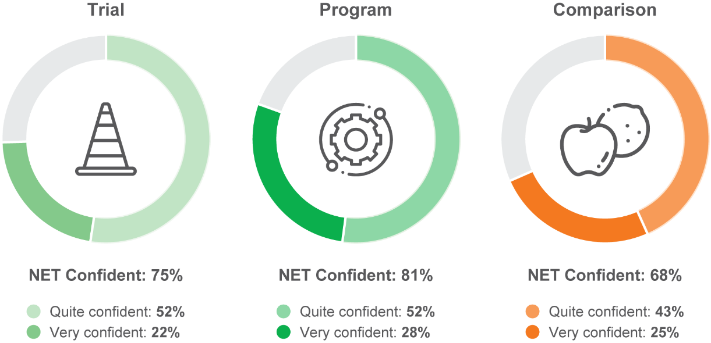

DA3: Overall how would you rate your confidence in using digital technology as part of your everyday life?

Base: All trial/program/comparison respondents (trial n=174, program n=558, comparison n=893)

During the qualitative fieldwork some participants mentioned that the course provided them with confidence to use their smartphone for job searching activities – something that was not explored prior to participating in the CTA program. Other participants highlighted the independence they gained by learning to use an email address.

* I [now]know how to go to SEEK, I know how to look up the jobs, put the keywords in. I can send my resume on my phone, where I didn't have any of that before … I hadn’t [connected to myGov] because I don’t have a computer or laptop. But yeah, she showed me how to do it, and yeah, I'm on LinkedIn and I’m linked into Centrelink with it.
* CTA participant in-depth interview
* I did have an email address, but I didn’t know how to use it … I used to get the person at the job place to do my emails … it just turned out to be too hard, I’d go there and then they’d be busy, and not much got done.
* CTA trial participant in-depth interview

There was a large variation in terms of CTA participant use of digital devices. Some were very capable while others needed a lot of instruction.

* Some people are really savvy with phones. That's what they’ve been brought up with. Us older generation tend to struggle with it, because we just pick the phone up and use it for a phone call. We’ve never had to use our phone as a miniature computer before. It makes it a little bit hard. There are some people who have never touched a computer before, or only ever used a phone.
* CTA participant in-depth interview

A series of general statements regarding technology were presented to survey participants. Looking at the key item of whether technology will result in more jobs, only half of the CTA trial and comparison groups agreed with this statement (Figure 19). This proportion was a little higher for the CTA program group than the other cohorts. Concerning whether technology usually improves people’s lives, the vast majority agreed with this, although the proportion agreeing was higher for CTA participants (81%) compared to the CTA trial participants (73%) or the comparison group (69%). Almost all survey participants, regardless of group, agreed that technology can give people ways to connect with each other.

Figure 19 Attitudinal sentiment regarding technology

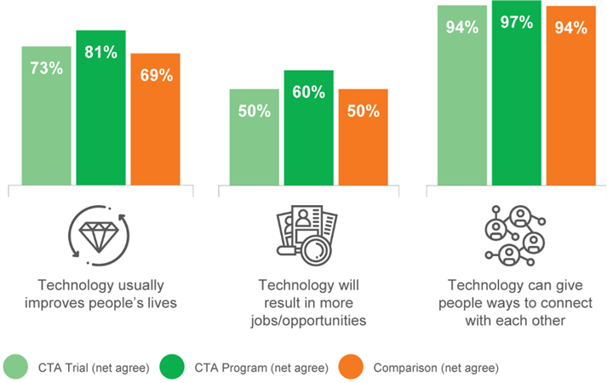

DA4: I am going to read out a number of statements about technology and would like you to tell me how much you agree or disagree with each one. A) Technology usually improves people’s lives C) Technology will result in more jobs/opportunities D) Technology can give people ways to connect with each other

Base: All trial/program/comparison respondents (trial n=174, program n=558, comparison n=893)

Some participants highlighted that the use of technology enabled them to keep in contact with family overseas by learning how to use videoconferencing – a skill learned from participating in the CTA program.

* It's very valuable, I've learned a lot more ... I didn’t even know how to even open the computer or to turn it off … now I can do an interview on Skype ... Especially like when I want to get in contact with my family to see how they're going because they’re in America.
* CTA participant in-depth interview

## Short-term outcomes

The findings in this section focus on short-term outcomes associated with digital literacy, increased confidence, and improved job search skills.

Confidence and resilience outcomes are related to the building of human capability that can improve the prospects for a mature age job seeker. In a broad sense, these impacts can improve an individual’s general quality of life. Many providers and respondents described situations and examples where the skills taught in the program were applied in settings not related to employment. For instance, digital literacy is important for keeping in contact with family and friends; this was particularly important during the period of COVID-19 restrictions. In addition, increased resilience and confidence in job seeking readily transfers to social settings.

**Nevertheless, development of human capability aspects is important for the development of human capital, and subsequent success in the job market**. The accumulation of human capability aspects, such as confidence and agency, can be key in positioning an individual to be able to learn and then leverage job search specific and digital skills in the pursuit of finding a job. For example, on their own, new skills in how to use LinkedIn or search for a role in a related industry may not be sufficient to enable successful job searching, unless they are underpinned by the confidence to engage with LinkedIn or the self-belief that the individual can successfully make the transfer across to a new industry.

### Improving digital literacy

The majority of respondents across both the CTA trial and the CTA program reported that the training received from their provider improved their ability to use digital devices. As shown in Figure 20, respondents in the CTA program were more likely to report this (78%) compared to respondents in the CTA trial (73%). Respondents who experienced COVID delivery were least likely (66%) to report improved ability to use digital devices. Similar, though slightly lower, results were achieved in the area of improving ability to use software.

Some participants appreciated the software training, which allowed them to gain familiarity with current packages and to increase confidence in using computers.

* I think it was good. I enjoyed that. I had used Office before, but only the earlier versions. And it's good to catch up and run the latest of the software and notice the differences.
* CTA participant in-depth interview
* I thought it was all helpful because it gave me a lot of confidence on the computer.
* CTA participant in-depth interview

Figure 20 Improved digital literacy

Improved your ability to use digital devices: CTA Trial 73%, CTA Program 78%, COVID Delivery 66%
Improved your ability to use software: CTA Trial 64%, CTA Program 72%, COVID Delivery 64%

EV1 a, c: I would like to know how strongly you agree or disagree that the training from <CTAPROVIDER>? A) Improved your ability to use digital devices (for example, smartphones, tablets, laptops and computers) C) Improved your ability to use software (such as MS Word, Excel and Outlook, Google docs, Apple Pages)

Base: All trial/program respondents who did the career assistance component (trial n=153, program n=558); all CTA COVID delivery respondents (n=650)

Figure 21 shows that over three-quarters of CTA program respondents (77%) agreed that the training they received from their provider encouraged them to use software, with slightly fewer CTA trial respondents agreeing (72%). Respondents who experienced COVID delivery were less likely to agree (67%). CTA program respondents were also more likely to agree that the training given by their provider improved their ability to connect with people using social networks (70%) compared to COVID delivery (65%) and CTA trial respondents (64%).

Figure 21 Increased ability to use digital platforms

Encouraged you to use software: CTA Trial 72%, CTA Program 77%, COVID Delivery 67%
Improved your ability to connect with people using social networks: CTA Trial 64%, CTA Program 70%, COVID Delivery 65%

EV1 d, b: I would like to know how strongly you agree or disagree that the training from <CTAPROVIDER>? D) Encouraged you to use software (such as MS Word, Excel, Outlook, Google docs, Apple Pages) more often B) Improved your ability to connect with people using social networks

Base: All trial/program respondents who did the career assistance component (trial n=153, program n=558); all CTA COVID delivery respondents (n=650)

Across all programs and delivery times, most respondents agreed that the training they received from their provider increased their digital job search activities.

As shown in Figure 22, about 4 in 5 respondents in the CTA program (81%) agreed that the training they received from their provider made them more open to using digital tools when looking for work, with slightly fewer (79%) respondents in the CTA trial agreeing. COVID delivery respondents were less likely to agree (77%). The same proportion of COVID delivery respondents (77%) agreed that the training improved their confidence in applying for jobs during the COVID-19 restrictions. Improved confidence in applying for jobs during COVID was most likely to be reported by CTA program respondents (88%), with a smaller proportion of CTA trial respondents agreeing (80%).

Participants in the qualitative fieldwork mentioned the benefits of the CTA program in providing many with additional avenues for finding work.

* And actually finding [jobs] online rather than sitting there looking into a paper and trying to find work.
* CTA participant in-depth interview
* Because I learned a couple of other different places that were always looking for workers that I wasn't aware of – so that was handy, definitely.
* CTA participant in-depth interview

As shown in Figure 22, most respondents in the CTA trial and CTA program (both 86%) agreed that the training delivered by their provider improved their confidence in looking for jobs online during the COVID-19 restrictions. Respondents who undertook the COVID delivery version of the training were less likely to report improved confidence (76%).

Figure 22 Increased use of digital job search activities

Made you more open to using digital tools when looking for work: CTA Trial 79%, CTA Program 81%, COVID Delivery 77%
Improved your confidence in applying for jobs (during COVID): CTA Trial 80%, CTA Program 88%, COVID Delivery 77%
Improved your confidence in looking for jobs online (during COVID): CTA Trial 86% CTA Program 86%, COVID Delivery 76%

EV1 e, f, g: I would like to know how strongly you agree or disagree that the training from <CTAPROVIDER>? E) Made you more open to using digital tools when looking for work F) Improved your confidence in applying for jobs G) Improved your confidence in looking and applying for jobs online

Base: All trial/program respondents who did the career assistance component (trial n=153, program n=558); all CTA COVID delivery respondents (n=650)

### Improving confidence

There were high levels of agreement from respondents in all 3 cohorts that the training they received helped them to gain confidence in themselves. Figure 23 shows that participants in the program were most likely to report this (87%) compared to the CTA trial and COVID delivery respondents (both 80%).

Figure 23 Improved confidence

I have gained confidence in myself from doing the training: CTA Trial 80% CTA Program 87%, COVID Delivery 80%

EV4e: Some of the training provided by <CTAPROVIDER> would have been in a group setting. I would like to know how strongly you agree or disagree with the following statements E) I have gained confidence in myself from doing the training

Base: All trial/program Wave 1 Group 1 and Group 2 respondents (trial n=174, n=558). All CTA COVID delivery in-person/group-based aspects were included (n=631).

Some participants mentioned how the CTA program provided them with confidence in applying for jobs.

* I think I learned that there’s a lot of people out there that are worse off than me. I suppose that is confidence. You tend to think of yourself at one level, and then you do a course like that and you sort of think, I'm not that bad. I guess that: there’s a bit of confidence in there.
* CTA participant in-depth interview

Overall, most respondents reported enhanced social connections resulting from the training’s group setting. However, this was more strongly the case for those in the CTA trial and CTA program compared to those who experienced COVID delivery. This sentiment was echoed during the qualitative fieldwork.

* I keep in contact with nearly everybody from that course. Yeah, we helped each other. I had to help [him] get his business and his ABN number and all that registered.
* CTA participant in-depth interview
* There’s a couple of people from the course that I keep in contact with, that I see around and I talk to them … we have a good conversation. And so that’s always good for them and always good for me.
* CTA participant in-depth interview

Based on discussions with CTA providers, one of the key benefits from this increase in confidence is that it allows some participants to take a greater degree of agency in their job search. Rather than viewing their lot in the job market as fixed, the confidence gained through the CTA program can enable them to consider their current position, and then chart a course forward towards a desired outcome.

As shown in Figure 24, the vast majority of CTA program respondents (94%) agreed that they enjoyed being able to mix with other people as part of the training, with a similar proportion of CTA trial respondents agreeing (92%). Compared to these 2 cohorts, respondents who experienced COVID delivery were less likely to agree (78%).

Respondents in the CTA program (87%) were most likely to agree that they had made friends with some people during the training, compared to 76% of respondents in the CTA trial. Contrastingly, just over half (53%) of respondents experiencing COVID delivery agreed that they had made friends with some of the people during the training.

* There were people that I did click with, yeah, and they are friends now, we still keep in touch and go and meet and that sort of stuff.
* CTA trial participant in-depth interview
* We really found there was a lot of us have become friends and stayed in touch with each other, even networking between each other which is an enormous asset. Especially with a lot of us that had life experience and know different things in different areas.
* CTA participant in-depth interview

Four in 5 respondents in the CTA program (80%) agreed that the training that they received from their provider made them feel more comfortable speaking up in a group setting, while respondents in the CTA trial were slightly less likely to agree (73%). Respondents experiencing COVID delivery were the least likely to agree that they felt more comfortable speaking up in a group setting because of the training (67%).

* I would rather us talking face to face because you got a chance to be more yourself.
* CTA participant focus group
* I waited until it was face to face, because it’s no good putting me on Skype and the like … Too distracting because there’s too many people on it, talking rubbish. It just doesn’t work.
* CTA participant in-depth

Figure 24 Social connections

I enjoyed being able to mix with other people as part of the training: CTA Trial 92%, CTA Program 94%, COVID Delivery 78%.
I made some friends with some of the people on the training: CTA Trial 76%, CTA Program 87%, COVID Delivery 53%.
Participating in the training made me more comfortable speaking up in a group setting: CTA Trial 73% CTA Program 80%, COVID Delivery 67%.

EV4d, b, a: Some of the training provided by <CTAPROVIDER> would have been in a group setting. I would like to know how strongly you agree or disagree with the following statements D) I enjoyed being able to mix with other people as part of the training B) I made friends with some of the people on the training A) Participating in the training made me more comfortable speaking up in a group setting

Base: All Wave 1 Group 1 and Group 2 trial/program respondents (trial n=174, program n=558). All CTA COVID delivery in-person/group-based aspects were included (n=631).

While respondents engaged in COVID delivery were less likely to report enhanced social connections and confidence to speak up in a group setting because of the training, 71% of this cohort did agree that participating in CTA helped ease the isolation caused by the COVID-19 restrictions.

A number of COVID delivery qualitative participants discussed the benefits of the social connectivity arising from participation in the CTA program during the COVID-19 restrictions. The interactions provided welcome relief from the sense of isolation many participants were feeling as a result of various restrictions. In some cases, this additional social connectivity was helpful in motivating participants in their job searching.

* I probably got more motivation to look for jobs. Also because of COVID there’s isolation around, even using Zoom, not having face to face but mentally – good way to communicate with somebody, that’s what I appreciate.
* CTA participant (COVID delivery)
* We were in lockdown, you appreciate the communication, everyone in same position, learning from others – as an older group struggling to get jobs.
* CTA participant (COVID delivery)

### Job search skills

Overall, respondents who undertook the digital literacy component of the CTA program were likely to report enhancements in their job search skills. This enhancement was particularly in relation to undertaking research to identify realistic and relevant job opportunities, and in applying for jobs.

As shown in

Figure 25, 9 out of 10 respondents in the CTA program (90%) agreed that the training helped them to identify skills they already possessed that could be transferred to other jobs or industries. A slightly smaller proportion of those undertaking COVID delivery (86%) and those in the CTA trial agreed (85%).

* They talked about things that you’ve done, that you perhaps didn’t relate to, and skills that you actually didn’t know that you had, and how you could use your past experience to expand the selection criteria of a job … because it gave you the stimulus to think left of field, and from a personal point of view, it gave me stimulus to just basically have a crack at anything.
* CTA participant in-depth interview

There was also strong agreement across the cohorts that the training helped them to understand the different ways that they can search for and apply for jobs. Agreement was strongest among the CTA program respondents (91%), compared to the COVID delivery (85%) and CTA trial respondents (83%).

The majority of respondents felt that the training helped them to create better targeted job applications, with 91% of the CTA program respondents agreeing. A slightly smaller proportion of CTA trial (89%) and COVID delivery respondents agreed (86%).

About 3 in 4 CTA trial (74%) and COVID delivery respondents (75%) agreed that the training encouraged them to submit a greater number of online job applications compared to about 4 in 5 CTA program respondents (83%). During the qualitative fieldwork, a number of participants discussed how their confidence in preparing online job applications had improved after participating in CTA.

* I’d apply for work and it meant that you’d go for an interview … it’s all done online now, and I can do that now. So that’s made me feel a lot better now about applying for online jobs.
* CTA participant in-depth interview
* Before the course I’d certainly looked at some things on SEEK … but for me it was a very long-winded process because I wasn’t a comfortable operative of those things. So certainly, in terms of searching, and if you wanted to apply and all those things, within reason I can do it with my eyes shut now.
* CTA participant in-depth interview

While most respondents across the 3 cohorts agreed that the training provided them with skills to perform better at job interviews, they were less likely to agree that the skills they learned helped them to get through to more job interviews. CTA program participants were the most likely to agree that the training provided them to better perform at job interviews (86%), with a slightly smaller proportion of CTA trial (83%) and COVID delivery (80%) respondents agreeing.

After completing the training, some participants still expressed apprehension about job interviews. However, others referred to the benefits they gained during the CTA training. Some participants felt that age discrimination was a further barrier they faced once they made it to interview.

* I still get nervous going to them [interviews], but yeah. I am prepared and I guess the course taught me to research the company, all that sort of stuff, that you’re going to know as much about the company as you can.
* CTA participant in-depth interview
* I’ve heard that from many participants that have been quite successful in getting job interviews when they’re interacting via the written word or via phone, but as soon as they turn up in person, it becomes a different experience … and that’s something that this course tries to help.
* CTA participant focus group

Of all the job search skill measures, the skills relating to helping to get through to more job interviews had the lowest level of agreement among the 3 respondent cohorts. While two-thirds of CTA program respondents agreed (66%), there were lower levels of agreement for both the CTA trial (60%) and COVID delivery cohorts (57%).

Figure 25 Improving job search skills

Section header: Research 
Helped you identify the skills you already have that could be useful for other jobs/industries: CTA Trial: 85%, CTA Program 90%, COVID Delivery 86%
Helped you understand the different ways that you can search and apply for jobs: CTA Trial 83%, CTA Program 91%, COVID Delivery 85%
Helped you to better understand the kinds of jobs and industries: CTA Trial 84%, CTA Program 88%, COVID Delivery 76%
Section header: Application
Helped you create job applications that were better targeted: CTA Trial 89%, CTA Program 91%, COVID Delivery 86%
Encouraged you to submit a greater number of online job applications: CTA Trial 74%, CTA Program 83%, COVID Delivery 75%
Section header: Interview
Provided you with skills to perform better at job interviews: CTA Trial 83%, CTA Program 86%, COVID Delivery 80%
Helped you to get through to more job interviews: CTA Trial 60%, CTA Program 66%, COVID Delivery 57%

EV3: I would like to know how strongly you agree or disagree that the training from <CTAPROVIDER> … ? A) Helped you identify the skills you already have that could be useful for other jobs or industries C) Helped you understand the different ways that you can search and apply for jobs E) Helped you to better understand the kind of jobs and industries where you might be able to find work nearby D) Helped you create job applications that were better targeted B) Encouraged you to submit a greater number of online job applications G) Provided you with skills to perform better at job interviews F) Helped you to get through to more job interviews

Base: Trial/program respondents who did the digital literacy component (trial n=167, program n=558). All CTA COVID delivery respondents were included (n=650).

## Experiences post-CTA

##### Activity at Wave 1

Respondents were asked about their situation soon after completing the CTA program (at the time of the Wave 1 survey). The question format allowed multiple responses, to reflect that participants may simultaneously be involved in multiple activities. As shown in Figure 26, nearly 9 out of 10 CTA participants (88%) were looking for work, as were 7 out of 10 trial participants (70%). While 22% of trial participants were working, only 14% of CTA participants were. Interestingly, around 1 in 5 CTA participants were engaged in unpaid/volunteer work also.

Participants from the qualitative fieldwork provided insight about a range of experiences arising from their current activity.

* I went and volunteered for a little bit and did some volunteer work and then I thought, ‘Maybe I should get back into disabilities … go and get my Cert III’. I went and studied for that, did that. I was just finding the job market really hard to get a foot in the door.
* CTA participant in-depth interview
* I’m working now because of CTA and I hadn’t worked for over five years before that.
* CTA participant focus group
* I’ve had my own business for several years and I just knew that I needed to update skills to be marketable in the job sector.
* CTA participant in-depth interview

Figure 26 Respondent status immediately post-CTA

Looking for work: CTA Trial 70%; CTA Program 88%. 
Unpaid or volunteer work: CTA Trial 18%; CTA Program 23%.
Working: CTA Trial 22%; CTA Program 14%.
Studying or training: CTA Trial 16%; CTA Program 12%.
Started or working in your own business: CTA Trial 4%, CTA Program 3%.

CS1: At the moment, are you …

Base: All respondents (trial n=174, program n=558)

##### Working

Among respondents who were working, the majority were working fewer than 35 hours per week (See Figure 27) across all cohorts. Only 16% of CTA participants who were working said that they were working full-time hours (i.e. 35+ hours) while 29% of those from the trial and comparison groups who were working stated that they were working full-time hours.

Figure 27 Full-time versus part-time work

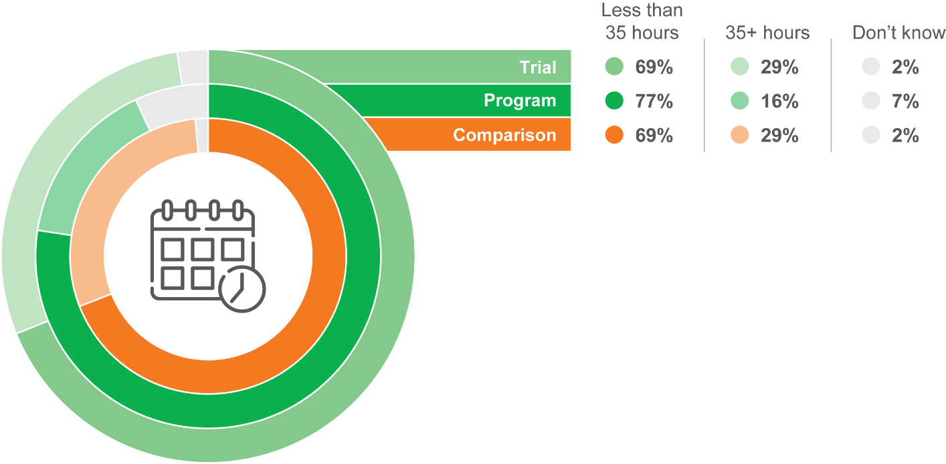

CS9: Altogether, how many hours do you usually work each week in your [CS3=01: main] job?

Base: Trial/program/comparison respondents who started in own business/working (trial n=38, program n=98, comparison n=378)

Of the survey respondents who were working, the majority were employed on a casual basis. As shown in Figure 28, this was particularly so for CTA participants, of whom 63% of those working were casual employees. Only 16% of CTA participants had a permanent position, while around a quarter of the trial and comparison groups were permanent employees. It must be noted that this is only one self-reported measure of employment category and does not necessarily indicate that CTA participants are more likely to move into casual work. It could be, for instance, that the cohort was more likely to be in this type of employment prior to participating.

Figure 28 Employment category

Permanent: CTA Trial 24%, CTA Program 16%, Comparison 26%
Casual: CTA Trial 50%, CTA Program 63%, CTA Comparison 52%
Contractor: CTA Trial 16%, CTA Program 9%, Comparison 12%

CS10: Are you working as a …  
Base: Trial/program/comparison respondents who started in own business/working (trial n=38, program n=98, comparison n=378)

Furthermore, among those who were employed, most were willing to work more hours if offered the opportunity. Again, this was especially true for CTA participants, of whom 88% were willing to work more hours. For the trial group, 79% were willing to work more hours, while 77% of the comparison group were also willing to work more hours.

Figure 29 shows that there were high levels of agreement among all respondents that their main job afforded them the opportunity to use their skills and abilities (95% and 87% for program and trial, respectively). The levels of agreement were similar for ‘I am able to gain useful experience’ (90% and 87%). There were also high levels of agreement that their job enabled them to learn new skills (both 75%). Despite this, there were also considerable levels of agreement that their current job was temporary until something better came along. Agreement with this statement was particularly high among CTA participants (58%) compared with the comparison group (41%) and the trial group (37%).

* Basically, I’ll just stick with what’s going on now. It is only a temporary, casual thing but I’ll just stick with what’s going on at the moment. I’ll take each day as it comes, so once this has finished, I’ll start looking again.
* CTA participant in-depth interview

Figure 29 Self-evaluation of quality of main job

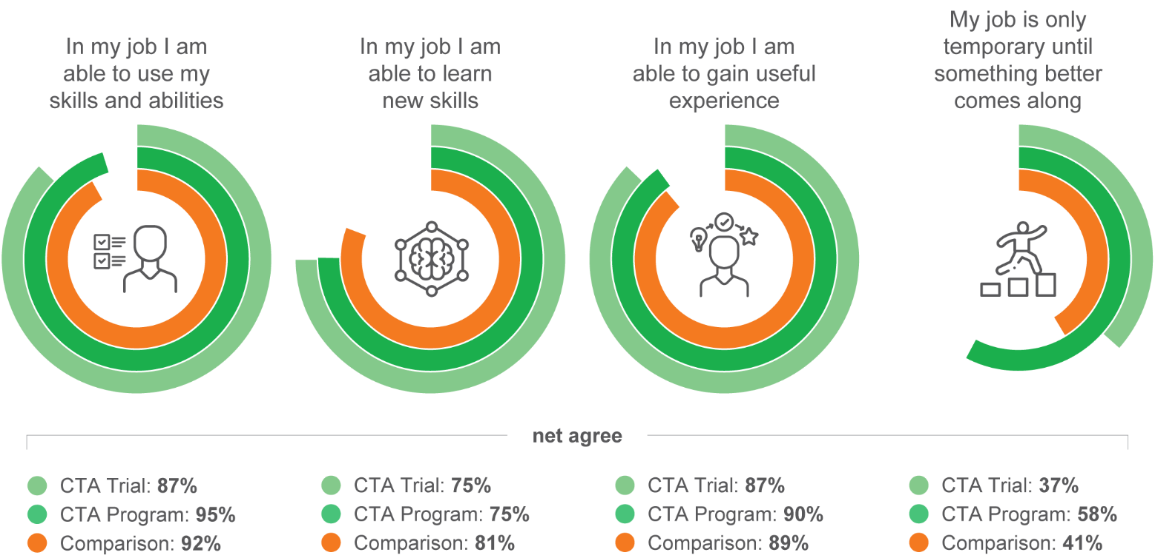

CS12: Now I’m going to read a list of statements about your job and I’d like you to tell me how strongly you agree or disagree with each. A) In my [CS3=01: main] job I am able to use my skills and abilities B) In my [CS3=01: main] job I am able to learn new skills C) In my [CS3=01: main] job I am able to gain useful experience D) My [CS3=01: main] job is only temporary until something better comes along

Base: Trial/program/comparison respondents who started in own business/working (trial n=38, program n=98, comparison n=378)

In a question included in later waves of the survey, participants were asked how long after completing the CTA program they secured their job. Around 1 in 7 (14%) had secured the job within 4 weeks of completing CTA. Almost half secured the job between 5 and 12 weeks (46%), with a further 11% securing the job between 13 and 26 weeks.

##### Job searching

Of those participants who were looking for work at the time of the Wave 1 interview, around one-third had secured a job interview since completing the CTA program (35% among trial participants, and 30% among CTA participants), similar to the proportions in the comparison groups (27%).

Participants generally felt the CTA program was helpful in getting them to the interview stage. As shown in Figure 30, 71% of trial interviewees felt the CTA program had helped them either a little or a lot, while the figure was 91% among CTA program participants. Across both groups, the proportions who felt that their jobactive provider had assisted them to get through to the interview were 54% and 71%, respectively.

Figure 30 Helpfulness of CTA and jobactive providers in getting through to the interview stage

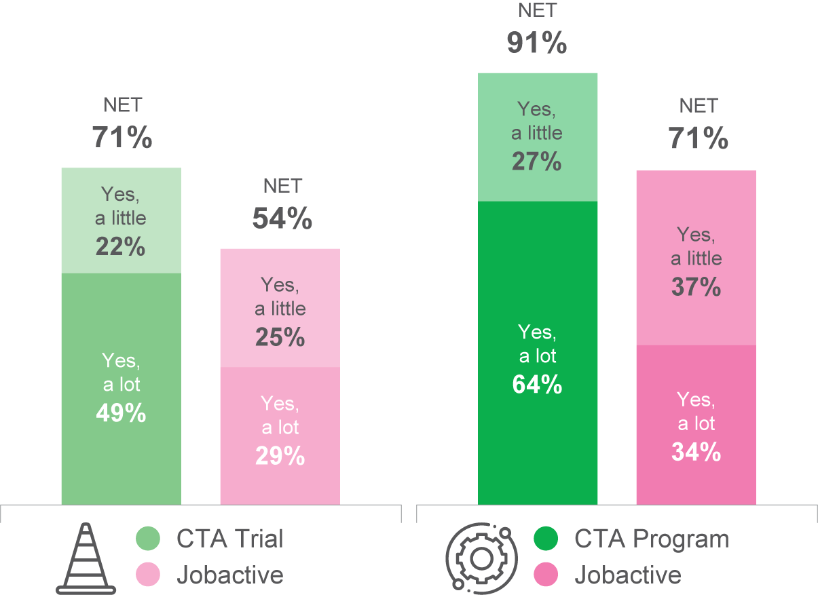

CS20: How much would you say participating in the training from <CTAPROVIDER> helped you to get this interview / these interviews, if at all?

Base: Group 1 and Group 2 respondents who are looking for work and had a job interview (trial n=43, program n=145)

CS22: How much would you say the advice and assistance you received from your jobactive provider has helped you to get these interviews, if at all?

Base: Looking for work (trial n=43, trial (with jobactive provider) n=118, program n=145, program (with jobactive provider) n=489)

As shown in Figure 31, when asked to identify which was the most valuable aspect of assistance from CTA, the most popular response was assistance with résumés (30%). The remaining aspects identified were a mix of specific skills such as job search or computer skills (11% and 9%, respectively) and more general confidence and motivation (18%). Only 8% mentioned ‘help with interviews’.

* I know how much I can transfer, like transferable skills. I know I have a lot more skills than I thought I did and can transfer to other jobs and so I can apply for jobs I would not have before.
* CTA participant
* (The digital literacy training) certainly made me a lot more confident with applying for jobs, which I probably wouldn’t have thought of before.
* CTA participant

Figure 31 Most valuable aspect of the assistance from the CTA provider

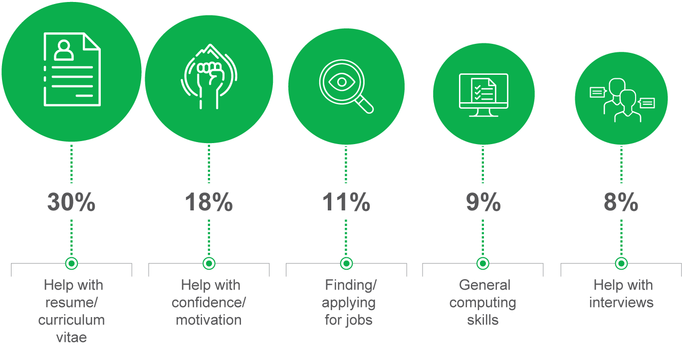

CS21: What was the most valuable aspect of the assistance from <CTAPROVIDER>?

Base: Group 1 and Group 2 trial and program respondents who are looking for work and had a job interview (n=162)

Most participants who were looking for work at the time of the Wave 1 interview were either very or fairly confident of finding work in the next 12 months. As shown in Figure 32, the proportion of CTA program participants with these levels of confidence (69%) was higher than among CTA trial participants (59%) and comparison group members (55%).

* … it’s already been successful twice … I walked in because it put me in touch with a direct employer that’s right in my area.
* CTA participant in-depth interview
* (CTA) made me feel more confident to get out there on the internet and start searching for jobs, because I was confident that what I was doing was 100 times better than what I was able to do before, so it made a big difference.
* CTA participant in-depth interview
* Just the ability to do the reprogramming to a certain extent, is like breaking it all down, and giving us a sense of resilience because there’s no immediate answers. And there’s no immediate solutions, and giving us a sense of resilience, and a sense of self-worth, and understanding, just helps us manage the knock backs that we get along the way, in respect of not being successful in employment.
* CTA participant in-depth interview

Figure 32 Confidence in finding a job in the next 12 months

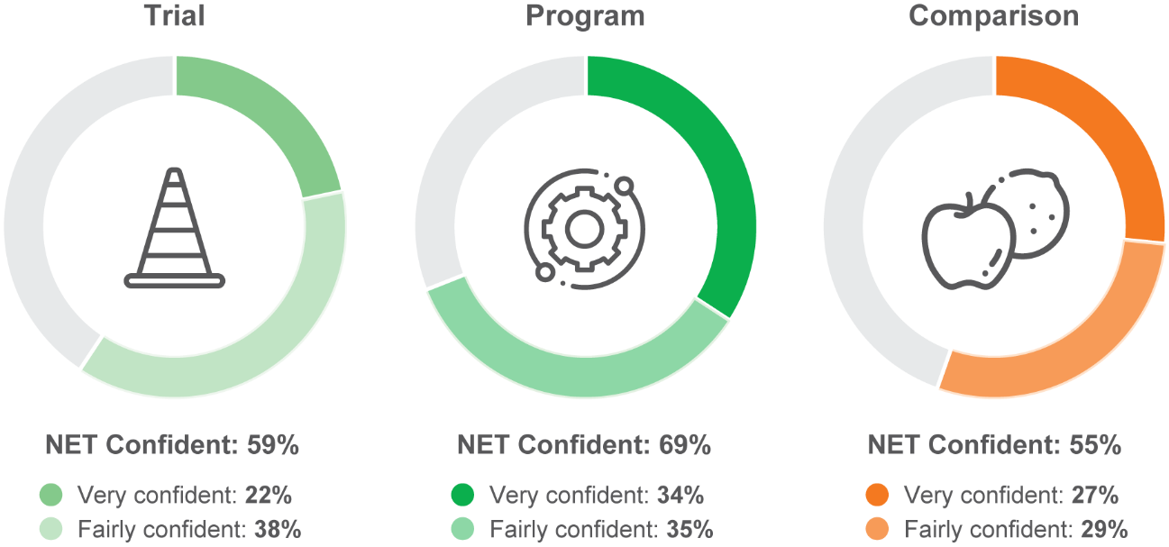

CS23: How confident are you about finding a [IF CS1 = 02 or 03: new] job within the next 12 months?

Base: Trial/program/comparison respondents who are looking for work (trial n=122, program n=494, comparison n=565)

## Longer term outcomes

The data in this section is based on the respondents included in the longitudinal analysis. These are the respondents who responded at each of survey waves 1 to 4. An additional Wave 5 survey was conducted, for a smaller number of respondents from the early streams. Given that these responses are filtered to only include respondents who participated across each of the waves, base sizes and frequencies differ from the reporting of Wave 1 in the previous section.

### Results from the longitudinal analysis

##### Employment outcomes

The question asking about respondents’ current situation was asked as a multiple response question. However, in this section, the responses are recoded so that each respondent is allocated a response that reflects the status at their highest level of engagement with the workforce. Results over time are plotted in Figure 33.

The top half of Figure 33 shows the CTA trial and its comparison cohort. For the CTA trial and its equivalent comparison cohort, a higher proportion of comparison respondents were working at each stage. Overall, however, the relative proportions remain broadly similar – as evidenced by the parallel lines. A marked dip can be observed at the time of the Wave 3 surveys, which broadly coincides with the rapid decline in the labour market associated with the COVID-19 lockdowns in early 2020. (Note the low base sizes for data in this part of the figure. Results should be considered indicative.)

The bottom half of Figure 33 shows the CTA program and its comparison cohort. For the CTA program and the equivalent comparison cohort, a different pattern emerges. While the comparison group always had a higher percentage working, the gap decreased markedly across the study period. The gap of 25% at the time of Wave 1 decreased to just 10% at the time of the fifth and final wave.

Figure 33 CTA percentage working by wave

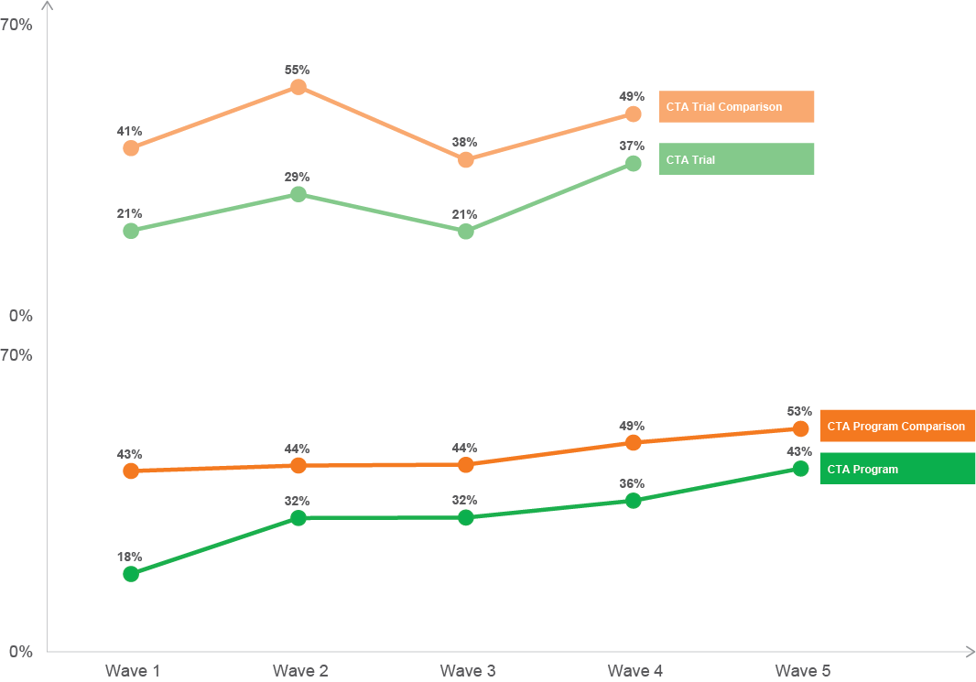

CS1: At the moment, are you …

Base: All respondents (CTA program waves 1–4 n=181, Wave 5 n=38, CTA program comparison waves 1–4 n=159, Wave 5 n=39, CTA trial waves 1–4 n=59, CTA trial comparison waves 1–4 n=19)

Figure 34 shows the activities undertaken by CTA program participants across survey waves 1 to 4. Consistent with the findings of Figure 33, a notable feature of Figure 34 is the increasing proportion of participants who are working across each of the waves (represented by the green wave-to-wave path). Another notable feature of participants’ post-CTA pathways is that some of those looking for work in one wave are subsequently in training or study at the next. While many return to looking for work, others move on to employment.

Figure 34 Post-CTA pathways

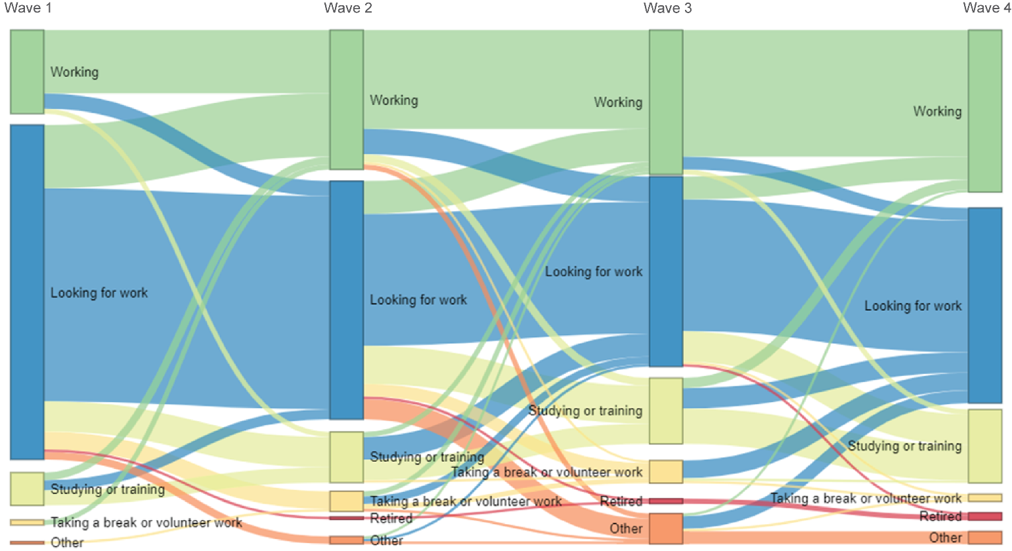

CS1 At the moment, are you …

Base: All CTA program respondents (CTA program Wave 1 n=181, Wave 2 n=181, Wave 3 n=181, Wave 4 n=181, Wave 5 n=38)

Figure 35 shows the trajectory of participants employed over time for the different survey streams. Stream 5 was the first CTA program stream and comprised participants who completed the program around September 2020. Streams 6 and onwards were drawn at subsequent monthly intervals.

A third of Stream 5 were already working at Wave 1. By Wave 6, the proportion working had risen to 44%. A group comprising streams 6 and 7 had a similar proportion working at Wave 5 (42%), but it rose from a lower base (only 18% working at Wave 1).

Similarly, a group comprising streams 8, 9 and 10 started from an even lower base (only 12% working at Wave 1) and rose the same number of percentage points from Wave 1 to Wave 5 (24 percentage points), as did streams 6 and 7.

As a proportion, streams 8 to 10 rose the most, with the proportion working having tripled from Wave 1 to Wave 5. The decreasing Wave 1 employment levels are likely to be caused by the labour market conditions, which were affected by the COVID-19 restrictions. This was a factor for CTA participants from Stream 6 onwards. Pleasingly, the trajectories of the group comprising streams 6 and 7 and the group comprising streams 8 to 10 are notably steeper than for Stream 5. This indicates that the impact of the 2020 COVID-19 restrictions on the labour market were short lived.

Figure 35 Proportion of CTA program participants working over time, by stream

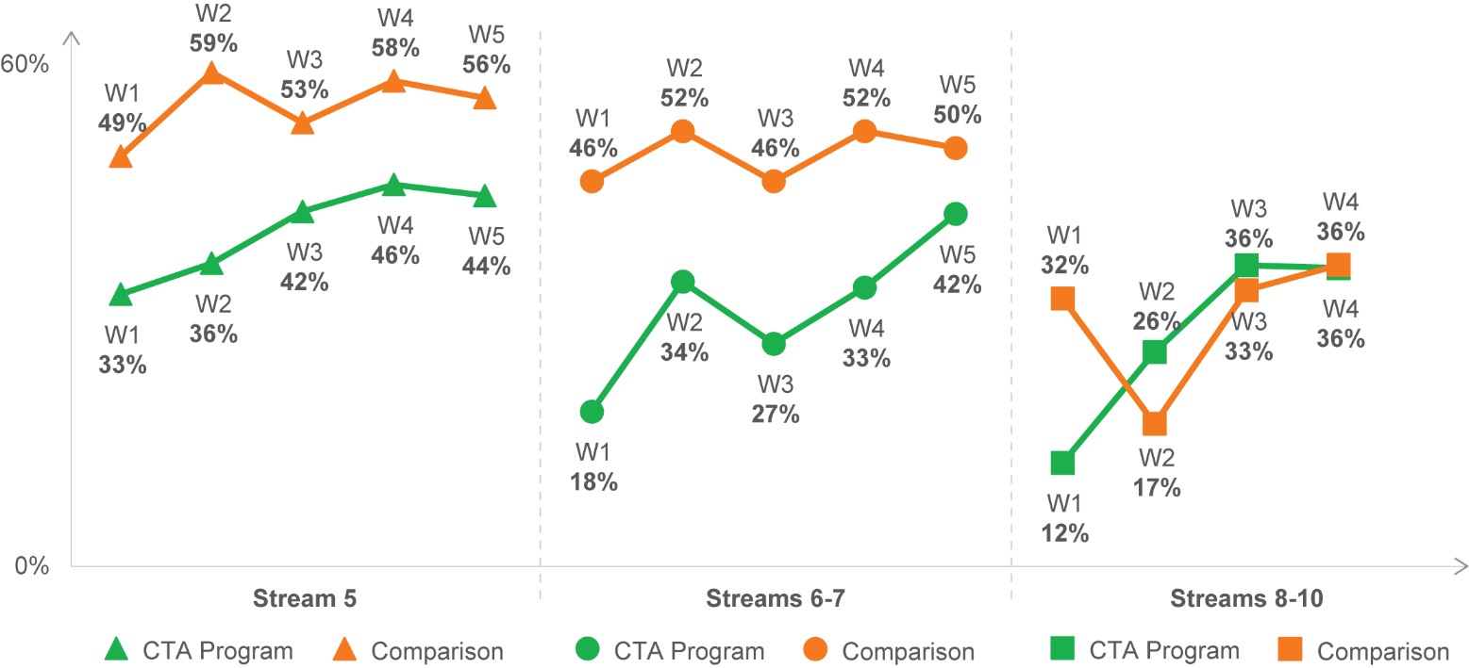

CS1: At the moment, are you …

Base: All program/comparison respondents – Status – Recoded – Working (CTA program Stream 5 Wave 1 n=22, Wave 2 n=22, Wave 3 n=22, Wave 4 n=22, Wave 5 n=18; streams 6–7 Wave 1 n=87, Wave 2 n=87, Wave 3 n=87, Wave 4 n=87, Wave 5 n=14; streams 8–10 Wave 1 n=52, Wave 2 n=52, Wave 3 n=52, Wave 4 n=52; comparison Stream 5 Wave 1 n=52, Wave 2, n=52, Wave 3 n=52, Wave 4 n=52, Wave 5 n=23; streams 6–7 Wave 1 n=82, Wave 2 n=82, Wave 3 n=82, Wave 4 n=82, Wave 5 n=24; streams 8–10 Wave 1 n=52, Wave 2 n=52, Wave 3 n=52, Wave 4 n=52)

##### Digital comfort outcomes during COVID

During late 2020, participants were asked whether the COVID-19 restrictions had changed their use of digital activities. The results are shown in Figure 36. Overall, the activities that increased the most as a result of the COVID-19 restrictions were use of digital devices and use of websites to access information and news. Participants in the CTA program were more likely to say they increased their use of technology to undertake aspects of their job online (31%) and to use the internet to apply for jobs online (30%), compared to the comparison cohort (25% and 26%, respectively).

Figure 36 Percentage who had increased their use of various digital activities

Section heading: Job search activities
Digital devices: CTA Trial 36%, CTA Program 41%, Comparison 42%
Technology to undertake aspects of your job online: CTA Trial 21%, CTA Program 31%, Comparison 25%
The internet to apply for jobs online: CTA Trial 25%, CTA Program 30%, Comparison 26%
Section heading: Social activities
Websites to access information and news: CTA Trial 34%, CTA Program 36%, Comparison 36%
Video conferencing to keep in touch with friends: CTA Trial 23%, CTA Program 34%, Comparison 31%
Retail websites or mobile shopping apps: CTA Trial 25%, CTA Program 25%, Comparison 30%
Telehealth or education online through video conferencing: CTA Trial 16%, CTA Program 21%, Comparison 19%
Social media to keep in touch with friends: CTA Trial 25%, CTA Program 18%, Comparison 21%

CS32: To what extent have you changed your use of the following digital activities as a result of COVID-19. Has your use of … A) Digital devices (for example smartphones, tablets, laptops, computers) H) [CS1=02 OR 03 ONLY: Technology to undertake aspects of your job online] G) [CS1=01 ONLY: The internet to apply for jobs online] E) Websites to access information and news C) Video conferencing (for example Zoom or Microsoft Teams) to keep in touch with family and friends D) Retail websites or mobile shopping apps to buy and sell things online F) Services such as telehealth or education online through video conferencing platforms (for example Zoom or Microsoft Teams) B) Social media (for example Facebook, Instagram, LinkedIn) to keep in touch with family and friends

Base: All trial/program/comparison respondents (A–F trial n=53, program n=181, comparison n=169; G trial n=32, program n=118, comparison n=82; H trial n=18, program n=66, comparison n=84)

Note: CTA trial participant cohort includes all CTA trial participants due to low sample sizes. This cohort may include participants who completed one or both of the 2 components available to trial participants: Functional Digital Literacy and Tailored Career Assistance.

Late in 2020, CTA participants were asked whether the training as part of the CTA program enabled them to better adapt to the changing landscape associated with the COVID-19 restrictions, in terms of both digital activity and finding employment. The results are shown in Figure 37. Overall, a majority of CTA program participants agreed that CTA had made them more confident and open to using digital technology when looking for jobs. Around 6 in 10 also agreed that the CTA training had made them more open to using new technologies (59%) and had made it easier to adapt to new technologies (61%). Compared to trial participants, CTA participants consistently had higher levels of agreement regarding adapting to new technologies, as well as being more open to using digital technologies during the COVID-19 restrictions.

Figure 37 Percentage net agree: during COVID-19

Easier for me to adapt to new technologies: CTA Trial 52%, CTA Program 61%
More open to using digital technology: 46%, 59%
Increased confidence in my ability to look and apply for jobs online: CTA Trial 57%, CTA Program 59%
Increased confidence when applying for jobs: CTA Trial 59%, CTA Program 56%
More open to using digital technology when looking for work: CTA Trial 57%, CTA Program 56%
Able to better adapt to changes in my job: CTA Trial 44%, CTA Program 47%

CS33: To what extent do you agree or disagree with the following statements. Because of the training through the CTA Program … B) It was easier for me to adapt to new technologies in my everyday life during COVID-19 A) I was more open to using digital technology during COVID-19 E) [CS1=01 ONLY: I had increased confidence in my ability to look and apply for jobs online during COVID-19] F) [CS1=01 ONLY: I had increased confidence when applying for jobs during COVID-19] D) [CS1=01 ONLY: I was more open to using digital technology when looking for work during COVID-19] C) [CS1=02 OR 03 ONLY: I was able to better adapt to changes in my job during COVID-19]

Base: All trial/program respondents (A–B trial n=53, program n=181; C trial n=18, program n=66; D–F trial n=32, program n=118)

##### Health and wellbeing outcomes

CTA participants were asked to self-describe their overall physical and mental health at each wave of the survey. As shown in Figure 38, for both CTA trial and CTA program participants, there was little variation in self-described physical/mental health across the waves, with 6 to 7 in 10 describing their health as excellent or very good. There was greater variation in the scores across the comparison cohorts, but overall, self-reported health and wellbeing of CTA participants was generally similar to that of the comparison group.

Figure 38 Self-described physical and mental health over time

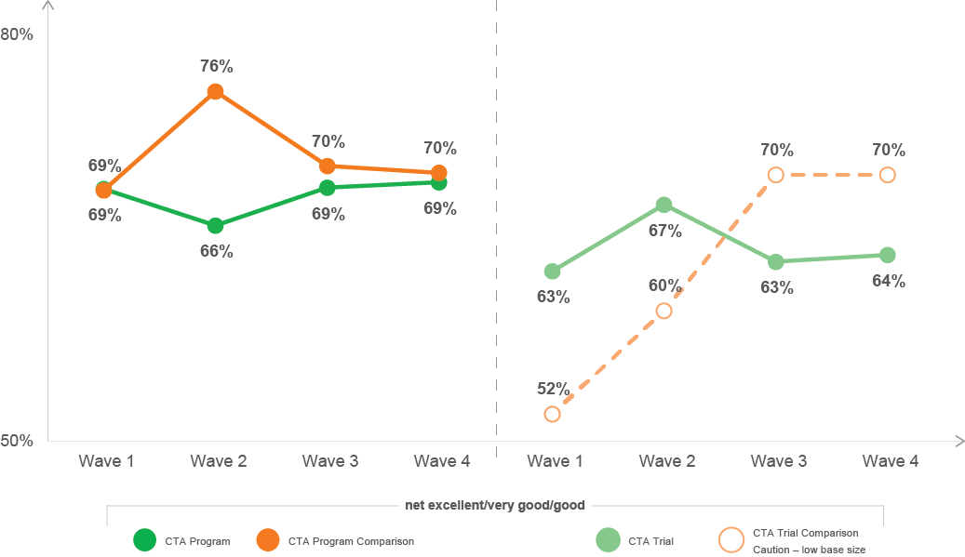

H1: We would now like to ask you some questions about your physical and mental health. In general, would you say your health, including both physical and mental health is …?

Base: All respondents (CTA program Wave 1 n=181, Wave 2 n=181, Wave 3 n=177, Wave 4 n=85; CTA program comparison Wave 1 n=159, Wave 2 n=159, Wave 3 n=155, Wave 4 n=54; CTA trial Wave 1 n=59, Wave 2 n=59, Wave 3 n=58, Wave 4 n=50; CTA trial comparison Wave 1 n=19, Wave 2 n=19, Wave 3 n=19, Wave 4 n=19)

The improvement in mental health arising from participation in the CTA program was mentioned spontaneously on many occasions during the qualitative fieldwork. Many participants claimed that social interaction positively impacted their mental health.

* It was more the social interaction, the mixing with people. Working as a team. Improving my mental health. Improving my self-esteem. It was a pleasure to work with a team of other people. For me, it was mostly about mental health growth.
* CTA participant in-depth interview

Respondents were also asked a series of 6 questions that can be used to indicate the potential presence of mental health illness.[21] As shown in Figure 39, results for CTA participants were largely stable across the 5 waves, with around 9 in 10 participants providing responses that suggest ‘no probable severe mental illness’.

Figure 39 Percentage no probable severe mental illness

Visual representation of findings outlined in previous paragraph
CTA Program values range from 90% to 92% across Wave 1 to Wave 4
CTA Program Comparison values range from 83% to 90%

H2: The following questions are about your feelings in the past 4 weeks. In the past 4 weeks, how often did you feel …?

Base: All respondents (CTA program Wave 1 n=175, Wave 2 n=174, Wave 3 n=174, Wave 4 n=177; CTA program comparison Wave 1 n=152, Wave 2 n=155, Wave 3 n=158, Wave 4 n=157)

Figure 40 shows the proportion of respondents who rated a variety of resilience indicators as either ‘very much’ or ‘often’ like them.

While some measures were similar across the CTA and comparison groups (e.g. having clear goals, and keeping cool under stress), the CTA trial and CTA program cohorts were less inclined to feel positive about the future (49% and 55% respectively) than the comparison group (61%). However, some respondents in the qualitative fieldwork indicated that participating in the CTA program improved their resilience and confidence.

* It brought my confidence back up on skills I had, but I haven’t used for a while. Skills like computer skills. I was working in offices but I haven’t been working for a while. I found that some things I had forgotten … It helped me remember how to work things out.
* CTA participant in-depth interview
* They provided us with a sense of confidence. They helped people to overcome a lack of self confidence. One person was not piping up and the facilitator gave her some confidence by saying that there is no fear in talking in front of people. The following day she spoke up more in front of my team.
* CTA participant in-depth interview

Figure 40 Resilience in the last 12 months

I have confidence in my ability to solve a problem: CTA Trial 77%, CTA Program 70%, Comparison 78%
I keep my cool under stressful situations: CTA Trial 64%, CTA Program 60%, Comparison 63%
I feel positive about the future: CTA Trial 49%, CTA Program 55%, Comparison 61%
I have clear goals that I am working towards: CTA Trial 46%, CTA Program 45%, Comparison 46%
I lose motivation when things get tough: CTA Trial 18%, CTA Program 15%, Comparison 11%

RE1: Thinking about the last twelve months, to what extent do you agree with the following statements. D) I have confidence in my ability to solve a problem A) I keep my cool under stressful situations E) I feel positive about the future C) I have clear goals that I am working towards B) I lose motivation when things get tough

Base: All trial/program/comparison respondents (trial n=53, program n=181, comparison n=169)



# Delivery in the COVID context

In addition to the quantitative survey conducted with COVID delivery CTA participants, interviews were also undertaken with providers and participants to unpack the emerging issues relating to delivery of the program in the COVID-19 context. This section contains insights from these qualitative consultations.

## CTA delivery during COVID

##### Successful transition to online delivery

CTA providers made a considerable effort to continue to deliver the CTA program online and most were able to transition to online delivery in a relatively short time. Five providers ceased delivering services temporarily during the period.

CTA providers used a range of technologies and platforms depending on their existing systems or capabilities; this included:

* transferring curriculum to e-learning platforms
* development of online modules
* use of teleconferencing platforms such as Teams and Zoom
* use of file-sharing platforms such as Office 365
* use of web platforms including dedicated YouTube channels.

In terms of content and curriculum a number of providers were able to transfer existing content and curriculum online, while others needed to amend the curriculum and include additional content to better suit online delivery.

While most providers were pleased with how the transition to online delivery had been achieved, some noted that there were ‘hidden costs’ associated with online delivery which they had not fully considered before commencing the rollout. These included:

* providers purchasing or providing loan laptops and phones to enable internet access
* loan hardware donated by a service organisation
* employing additional staff as ‘digital mentors’ to assist participants to get online.
* … we actually put on staff, digital technology mentors … we hired two mentors, and then that way if participants required assistance in order to participate, either they didn’t have an email address, or they didn’t have knowledge on how to actually utilise the video conferencing technology, then those digital mentors would work with the participant, get them connected so that the trainers and the facilitators could just facilitate.
* CTA COVID delivery provider in-depth interview

##### Structure of the CTA program online

Discussions with providers regarding the structure of delivery during COVID revealed that a great variety of delivery modes were used during this time. This included variability in terms of the combination of delivery modes (e.g. Zoom sessions, discussion boards, email/telephone support and even hard-copy materials). It also included a great deal of variability in terms of how sophisticated providers were in terms of shifting to online delivery: while some providers effectively shifted existing content online, others took the opportunity to implement changes in the way content was delivered, including making key employers or speakers available across multiple CTA groups.

A number of CTA providers found that a key challenge for both participants and facilitators was having 8 hours of online delivery a day. Some CTA providers restructured the course to allow greater flexibility with shorter blocks of online delivery.

Other providers operating at a larger scale were in a position to adopt a model whereby some components were delivered to a larger group, then used location-based or topic-based breakout rooms. While acknowledging the efficiencies of scale that could be gained by large-group interactions, these providers still emphasised the importance of the small-group interactions, and the necessity for the material to be tailored to the local labour market of participants.

* I still wanted that we would all communicate, all be together initially on the large group sector, the Zoom session and do the component of the week that we were studying, for example, smart goals. Then once we had done that group piece, we would divide out into the breakout rooms, and people would go into a New South Wales breakout, for example, or if we were doing résumés and cover letters rather than a state breakout, it would be more, what part of it are you up to.
* CTA COVID delivery participant in-depth interview

##### Referrals to the CTA program during COVID-19 restrictions

The CTA program was originally funded from the Employment Fund available to jobactive providers. This significantly limited referrals from jobactive providers, who had little visibility of the CTA program in the early stages of its rollout. jobactive providers would choose to fund other interventions from the Employment Fund such as skill sets or licensing where they believed there were greater prospects of obtaining a job outcome.

The government’s decision to provide dedicated funding to the CTA program, separate from the Employment Fund, significantly increased referrals to the CTA program from jobactive providers.

Discussions with providers suggested that referrals during the period of COVID-19 restrictions were strong. This is in part because:

* the more difficult labour market as a result of COVID-19 meant that more job seekers were seeking additional support
* the shift to increased teleconferencing and online delivery of many services during COVID-19 restrictions has highlighted more than ever the importance of digital literacy skills
* a number of alternative employment programs such as Work for the Dole were not able to proceed, as a result of COVID-19 restrictions.

While referrals to the CTA program increased during the period of COVID-19 restrictions, they are still driven in part by the perceptions of jobactive providers as to which intervention or program provides the best employment outcome. The CTA program has not always been seen by jobactive providers as the program that would get the best employment results.

* … our referral rate increased at that point in time. The referral rate has increased through COVID and all I can put it down to is that it’s actually the fact that we were delivering online and this was something that jobactive could refer job seekers to. And obviously job seekers were willing to do that too.
* CTA COVID delivery provider in-depth interview

There was a view among some CTA providers that more could be done to promote case studies of successful outcomes from the CTA program.

There are some indications that referrals to CTA providers associated with TAFE colleges were not as strong. This may be due to a perception among jobactive providers that CTA providers based in TAFE institutes may have a greater focus on delivering training and do not have as strong a linkage with employers, which, in turn, may result in poorer employment outcomes.

##### Facilitators

Having effective and well-trained facilitators who could engage with and motivate participants and were empathetic to their needs was key to the successful delivery of the CTA program. While the transition to online delivery as a result of COVID-19 restrictions posed many challenges, facilitators overall were able to adapt relatively quickly to the changes. In a small number of cases where the facilitator was not able to adapt and had a strong preference for face-to face delivery, they chose to leave the program. In other instances, CTA providers engaged extra facilitators to assist with the transition to online delivery.

In many cases, however, there was an enlarged facilitator role brought about by the transition to online delivery. This involved some facilitators needing to both deliver training and provide a higher level of operational support for participants. In some cases this involved going ‘above and beyond’ to ensure new participants could access the program. One example included a facilitator dropping off course materials and hardware at the homes of potential participants. Some providers invested in pre-program support to enable this to happen more smoothly, for example using administrative support to pre-train participants in how to access the platforms.

* So we would deliver their laptop to them at their jobactive site, we would sit there for an hour. I used to show them how to use it, get them logged in, show them the system that they were going to use, teach them how to log into a Zoom meeting and things like that. So we started with sort of covering off this face to face, the phone, the Zoom and the online portal that they can access at any point in time now.
* CTA COVID delivery provider in-depth interview
* We had our admin people who would send the Zoom link. Sometimes it would take a half an hour to get them on. So, prior to even an interview, our admin staff would send the link to the potential participants, and then they would take care of instructing them on how to get onto Zoom. So by the time the program started, they would have had that initial, ‘this is how we get onto Zoom’.
* CTA COVID delivery provider in-depth interview

##### The impact of online delivery on one-on-one time and group sessions

A number of providers indicated that one-on-one time with participants increased as a result of online delivery. The increased efficiencies and self-directed learning with online delivery allowed facilitators to have more one-on-one sessions with participants.

Likewise, while the group sessions were an important and much-valued aspect of the face-to-face delivery of the CTA program, some providers indicated that the camaraderie and benefits of group sessions were not significantly impacted due to online delivery. Once participants were comfortable with the use of technology there was still strong interaction among participants. However, this experience was not universal. Some participants struggled to connect meaningfully with others in the group setting, and this result was borne out in the quantitative survey findings (see 5.2.2).

* Everyone spoke their mind and everyone was friendly and we helped each other. Some of the students would actually tell a little story about how some of the difficulties they had and we would all chip in and support them and encourage them, and I think that was great.
* CTA participant COVID delivery in-depth interview
* No, there was no group dynamic. I can’t remember how many weeks it was … But we didn’t forge any kind of connection in the group at all. I did with the trainer because she would call in occasionally and individually ring us, and check things.
* CTA participant COVID delivery in-depth interview

In response to the extraordinary situation with lockdowns and social isolation, some providers explicitly included wellbeing or mental health aspects in the program. While these were not universally viewed as a great success among participants, there was a consensus among providers that inclusion of these kind of aspects has the potential to be valuable. Quite apart from facing the trauma of a pandemic, the issues which confront mature age job seekers are such that making space for discussion of resilience or wellbeing is likely to be valued by participants.

* I think it probably helped a lot of people during COVID because they weren’t getting out and about, and to be able to sit in a group of 10 or 15 people and still have a chat, I actually think it was a good thing for them. Quite often I’d walk by the trainer and I could hear participants in the background having a laugh and asking each other questions.
* CTA COVID delivery provider in-depth interview

##### Employer visits

COVID-19 restrictions and subsequent changes to program delivery had both a positive and a negative impact in engaging with employers.

Many employers who had previously participated in the CTA program were fully focused on responding to COVID-19 restrictions and recession and keeping their business viable during the recession, and therefore did not have the time available for employer visits.

On the other hand, the use of online delivery allowed employers to have a one-hour online session without the need for site visits, and as a result a number of CTA providers were able to secure greater engagement with employers.

* It was very hard to get employers to come in to talk to the group, because everyone’s busy, as you can imagine. So it was very hard to get employers to actually come into the room to address the group. [During the COVID delivery period] I was able to get all these employers to come in and talk to the group, because it only took about 20 minutes to pull them out of their day. So, employer engagement went triple, even quadruple from the face to face delivery. We still do that now because it was so successful.
* CTA COVID delivery provider in-depth interview

## Challenges in delivery due to COVID-19 restrictions

##### Onboarding of applicants

The onboarding process for new participants was one of the most challenging aspects of transitioning to online delivery for providers.

This was particularly the case where participants had:

* low levels of digital literacy and in some cases no email account
* low levels of English proficiency
* no access to a computer
* poor internet connectivity.

To overcome these challenges CTA providers would assess applicants and, if they had a very low level of digital literacy, some CTA providers would suggest to applicants that they defer participation until face-to-face delivery was possible. Overall, however, most CTA providers would do whatever was possible to support applicants to participate in the program; it appears from interviews with providers that only a small proportion of participants were not accepted because of low levels of digital literacy.

* I would definitely say that the two biggest barriers would be the language barrier and technology because there were also some students that didn’t have access to any technology whatsoever as well. So, they've also had to wait for to face to face.
* CTA COVID delivery provider in-depth interview

##### Technological challenges

While there were a number of technological challenges faced in transitioning the CTA program online, providers as a whole responded well and exercised great initiative and adopted innovative delivery models to ensure that the ‘show could go on’.

It was found that most applicants had some form of technology, whether this be a tablet or a borrowed computer. Where applicants did not have their own computer or access to a computer, a number of CTA providers went to considerable lengths to support applicants in gaining access. This included:

* encouraging the use of a family member’s (often a son’s or daughter’s) computer
* providing a computer on a loan basis
* purchasing a computer for the participant’s use and having it couriered to their home.

While most CTA participants appeared to have sufficient data and broadband access, in some cases, particularly in regional areas, the CTA provider assisted in providing internet or data access.

##### Differences between public and private providers

It would appear that public providers, where the CTA program was delivered by a TAFE institute, were far less flexible in responding to online delivery.

Whereas private providers were able to pivot relatively quickly to online and remote delivery, an interview with one TAFE CTA provider indicated that their TAFE was not able to respond as quickly and they stopped delivery of the CTA program for the 6-week period when TAFE campuses were shut. The interview with the TAFE provider found that participants still wanted face-to face delivery and the TAFE institute had a network of 11 campuses, including in regional areas, to facilitate on-campus delivery of programs.

## CTA participant perspectives on delivery

##### Participant feedback relayed by CTA providers

Reinforcing the results of the CTA participant survey, interviews with CTA providers indicated that participant feedback they had received on the online delivery was generally positive. According to providers, it:

* allowed participants greater flexibility in attending sessions
* overcame some of the barriers faced by participants in terms of travel time and costs
* provided greater access to participants in regional areas
* required participants to use technology from the outset and in some respects increased the uptake and learning of digital literacy skills.

Feedback from some CTA providers was that completion rates improved as participants’ attendance increased and the greater flexibility offered by e-learning facilitated higher completion rates.



# Conclusions and recommendations



**What worked**

## What worked

|  |
| --- |
| CTA program design |

A focus on building and developing the individual

* A significant benefit of the CTA program has been its capacity to build confidence and to motivate mature age job seekers. These human capabilities are key precursors to or foundations for positive life outcomes, including employment outcomes.
* The structure and delivery of the CTA program treated mature age job seekers with respect and dignity, fostering a sense of self-worth. The program facilitated their reconnection with the labour market and provided intensive support at a time when disconnection can quickly become entrenched.

A tailored approach that addresses a need

* The CTA program provides a good combination of job search skills with digital literacy training, recognising the multiple barriers faced by mature age job seekers. It also addresses the challenges of structural adjustment in the economy and the needs of some mature age job seekers to identify their own transferrable skills so as to transition between sectors to secure employment.
* The CTA program addresses an increasing need for job seekers over 45 years and fills a gap for this growing cohort which cannot necessarily be fully addressed by jobactive providers given their extensive caseload. In addition to promoting and providing referrals to CTA themselves, jobactive providers reported that they often received interest from job seekers who had heard about the program by word-of-mouth.

Group settings are important

* A unique and highly valued aspect of the CTA program is the delivery of training in group settings to strengthen engagement and social interaction. Many participants expressed the view that this was one of the best aspects of the CTA program. The group setting allows participants to support each other and realise that there are other people who are in a situation similar to theirs. This is particularly important for mature age job seekers who have been unemployed for an extended period and may have become quite socially isolated.
* Some group members reported that their group stayed in touch, and that members were able to provide mutual ongoing support. Greater encouragement or facilitation of this opportunity could be considered by CTA providers.

**Continuity of service**

* The length and continuity of service, where participants are engaged for 2 to 3 full days over 8 weeks, helps establish a group culture and allows participants to develop a good rapport with the facilitator. Motivation and confidence were reported to improve due to regular exposure to the CTA program over a number of weeks.

Voluntary nature of the CTA program

* The voluntary nature of the CTA program is a key benefit, in that applicants are self-motivated to attend the course as opposed to participating for compliance reasons.

CTA program flexibility and management

* The department has played an important role through both the flexible design of the CTA program and minimising red tape and compliance obligations. It has also been responsive to implementation issues and learnings that arose, as well as supporting providers through marketing, advice, and other resources.



|  |
| --- |
| CTA program delivery |

The role of facilitators

* Having effective and well-trained facilitators who could engage and motivate participants and were empathetic to their needs was key to the successful delivery of the CTA program. In many cases, having a facilitator who was of a similar age helped in this regard. Facilitators were valued not just for their expertise in terms of job search or digital literacy but as a motivator, mentor and supporter of job seekers, providing encouragement and one-on-one support to build capability and self-belief for participants.

Flexibility and responsiveness of the CTA program to COVID-19 restrictions

* The benefits of the flexibility in the program’s design were particularly evident in its ability to respond rapidly and effectively to the COVID restrictions. Indeed, the program’s adaptation to COVID resulted in some delivery improvements that can potentially endure.
* The approach by the department to encourage providers to use innovative approaches to tailor the program to meet local needs enabled the CTA program to be flexible and responsive to changing needs. In response to the COVID-19 restrictions, most CTA providers demonstrated great agility and innovation in transitioning the CTA program to online and remote delivery, without pause and with strong engagement from participants.
* The use of online delivery during COVID-19 restrictions was successful, with positive feedback received from both participants and CTA providers. While there were a number of technological challenges faced in transitioning the CTA program online, CTA providers were largely able to innovate and overcome these. Most providers viewed the blended delivery model as appropriate into the future, particularly for those job seekers who found travel a barrier to attendance. The central challenge for future blended delivery models will be to ensure that benefits associated with the group dynamic are retained.

## Areas for improvement



**Areas for improvement**

Engaging with employers

* Industry engagement was a challenge for most CTA providers, in terms of both outbound site visits and inbound visits by employers to the CTA provider. In a number of cases participants were not provided with any opportunities to engage with employers. This is particularly important as participants placed a high value on engagement with employers, where it occurred, especially hearing first-hand about new industry sectors and what employers are really looking for. These site visits helped shape future career choices and even provided direct employment opportunities in some cases.
* The more flexible delivery models adopted during COVID-19 restrictions allowed for some innovative approaches to engage with employers, including virtual site visits or guest speaker presentations via teleconferencing or use of YouTube.

Referrals

* While referrals from jobactive providers to the CTA program were a challenge at the commencement of the program, this was helped considerably with the shift to using dedicated funding rather than the prior use of funding from the Employment Fund allocated to each jobactive provider. Some providers report that obtaining sufficient referrals is still a challenge.
* There were isolated reports of referrals being made for individuals who clearly had underlying issues preventing them from effectively engaging with the course. Increased awareness of the scope of the CTA program among jobactive providers, and more sophisticated screening of potential participants, is likely to benefit all parties.

Rolling enrolments

* The rolling enrolments under the CTA program, whereby participants joined the group at any stage of the course, was one of the commonly identified shortcomings of the program. While it provided some flexibility for the program in accepting intakes as needed, it did create challenges for participants, especially where there were smaller classes and new participants had different skill levels impacting on the dynamics of the group. For larger classes (generally 6–8+ participants), rolling enrolments were more seamless and had less impact on the participants, which suggests that careful case-by-case decisions are important.

## Recommendations



**Recommendations**

* Consideration of online components may allow a broadened reach based on geographies and differing levels of ability. It will potentially be even more important into the future given the increasing number of mature age job seekers and impacts of COVID-19 leading to increased use of digital technologies.
* The positive design elements of the CTA program, particularly its flexibility, use of group settings and trained facilitators, continuity of service and focus on transferable skills, should be considered and factored into the design and delivery of other employment-related programs.
* Given the success of providers in continuing to deliver the CTA program online during COVID-19 restrictions and the positive results from online delivery, consideration should be given to continuing to offer the program through a blended delivery model.
  + This is particularly relevant in remote and regional areas where there are thin markets and significant travel costs for participants.
  + This would also help extend the reach of the CTA program, increase flexibility, improve sustainability, reduce travel and other costs for participants and potentially increase the uptake of digital technologies.
  + It would need to be supported at referral stage by a checklist for technology support requirements in relation to appropriate devices and data plans. It may also need a small and separate bridging module for those requiring the very basic skills in accessing online delivery, albeit many CTA providers were able to address this during COVID.
* The department could look to strengthen the employer engagement model by promoting best practice examples of employer engagement and providing increased work experience opportunities. This would be valuable in terms of building skills in the workplace and also breaking down any potential barriers related to age.
* In terms of program design, there should be a greater focus on referrals, completions and employment outcomes, for example:
  + greater promotion of case studies and outcomes from the CTA program in order to support increased referrals from jobactive providers
  + providing visibility and feedback to CTA providers on employment outcomes and increased feedback from jobactive providers after the final ‘warm handover’.
* The department should work with CTA and jobactive providers to improve the quality of data on key outcomes from the CTA program including data relating to completion rates, improvements in job search activities (including the number of interviews secured), and employment outcomes.
* Consideration should be given to incorporating health and wellbeing elements into the program. This could include discussion of mental health issues, encouraging participants to monitor their mental health, referring and providing access to support services, and following up on participants post course completion.

1. Sample size: n=181 total across first 4 waves for CTA program participants, n=159 for comparison group.
2. Department of Employment, Skills, Small and Family Business (2019). *Changes in the Australian labour market: a 30-year perspective*.Available: <https://lmip.gov.au/default.aspx?LMIP/GainInsights/SpecialTopicReports>
3. Gustafsson, L (2021). Australian labour force

   participation: historical trends and future prospects, The Treasury, Commonwealth of Australia, Canberra.
4. Productivity Commission (2013). *An Ageing Australia. Preparing for the Future*, Commission Research Paper, Canberra.
5. Australian Government, Department of Education, Skills and Employment, jobactive Caseload 31 March 2020 (internal report, unpublished).
6. OECD (2020) *Employment Outlook*, Labour Force Participation Data.
7. Mills, A, Ng, S, Finnis, J, Grutzner, K & Raman, B (2020). *Hidden in plain sight: The impact of the COVID-19 response on mature-age, low-income people in Australia*, Brotherhood of St Laurence and Nous Group, Melbourne.
8. Australian Government, Department of Education, Skills and Employment, internal report (unpublished)
9. Australian Human Rights Commission (2016). National Inquiry into Employment Discrimination Against Older Australians and Australians with Disability, Sydney, pp. 56–7.
10. Australian Department of Employment, Skills, Small and Family Business (2019). *Employers’ experiences and attitudes to hiring mature age workers*. Available: <https://lmip.gov.au/default.aspx?LMIP/GainInsights/EmployersRecruitmentInsights>
11. National Skills Commission (2021). The Australian Skills Classification BETA Release 1.1. Available: www.nationalskillscommission.gov.au/our-work/australian-skills-classification#resources
12. National Skills Commission. Available: https://www.nationalskillscommission.gov.au/23-core-competencies-importance-set-base-transferable-skills
13. Thomas, J, Barraket, J, Wilson, CK, Holcombe-James, I, Kennedy, J, Rennie, E, Ewing, S, MacDonald, T (2020). Measuring Australia’s Digital Divide: The Australian Digital Inclusion Index 2020, RMIT and Swinburne University of Technology, Melbourne, for Telstra.
14. Perales, F, Higginson, A, Baxter, J, Western, M, Zubric, SR, Mitrou, F (2018) *Intergenerational Welfare Dependency in Australia: A Review of the Literature.* Life Course Centre Working Paper Series.
15. Anand, P, Hunter, G, Carter, I, Dowding, K, Guala, F, van Hees, M (2009).The Development of Capability Indicators. *Journal of Human Development and Capabilities*, 10(1), 125–152.
16. Bowles, M (2020) *Human Capability Reference Framework: Complete 7 Levels*. The Institute for Working Futures.
17. Comparison cohort: this is a group of non-participants who would be eligible for CTA but who have not been involved with the CTA program, and who have agreed to participate in the quantitative research.
18. Employment Services Outcomes Report (jobactive) 1 January 2019 to 31 December 2019, Australian Government, Department of Education, Skills and Employment.
19. Participants who responded to the question ‘Just so that we have some background about your experience with the program, can you tell me are you …’ with ‘Finished the program’.
20. ACIL Allen and Wallis (2020). *The Transition of the Australian Car Manufacturing Sector: Outcomes and Best Practice*, a report for the Australian Government, Department of Education, Skills and Employment.
21. <https://www.abs.gov.au/ausstats/abs@.nsf/lookup/4817.0.55.001chapter92007-08> The scoring of the K6 scale leads to an overall dichotomous result of ‘No probable serious mental illness’ or ‘Probable serious mental illness’.